The Space-Time Blade by URWERK

Geneva – 23 August 2023. URWERK embarks on a new groundbreaking journey, redefining the very essence of time through a fresh and captivating approach. No satellite hours or hours and minutes hand, nor even a case, dial or crown. Does this instrument even tell the time? Definitely – and beautifully – so! The expertise of talented craftsman Dalibor Farny has been enlisted to materialize this extraordinary vision. Brace yourself for an experience that will take your breath away.

Let us introduce you the URWERK’s Space-Time Blade: where Science-Fiction and Time-Telling meet in a masterpiece of glowing magic. Where hours, minutes, seconds and even kilometers converge in luminous symbiosis.
Let the Space-Time Blade’s illuminated digits guide you through the Spacetime continuum, as this remarkable glass column captures not only the hours, minutes, and seconds, but also kilometers, depicting our smooth Earthly journey. Encapsulated in glass by the talented Dalibor Farny, this incredible creation blends artistry and precision, inviting you to venture into a world where time itself becomes luminous.

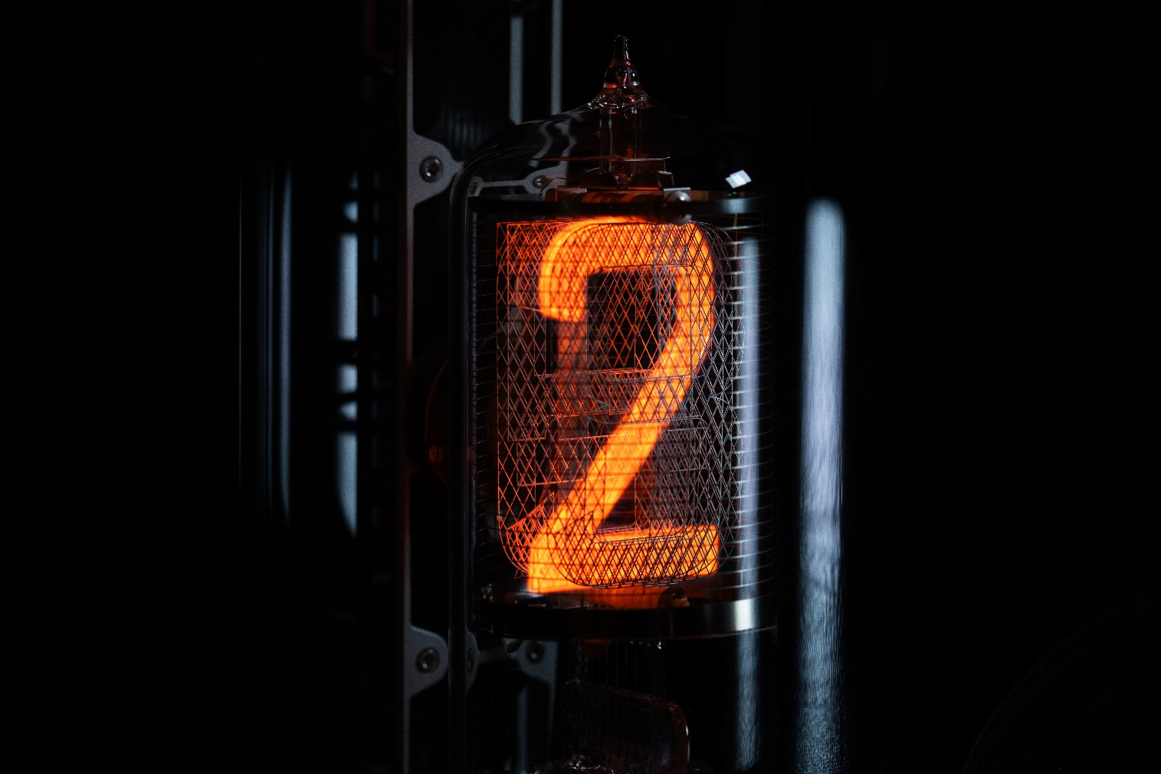

At the heart of this exceptional clock lies an incandescent and almost nostalgic tribute to Nixie tubes: introduced in the 1950s, these soon gained popularity as a unique way to display numerals using glow discharge.

Standing 1.62 m tall and weighing 40 kg, the Space-Time Blade has been designed to match URWERK's dreams. Its base is an URWERK bronze crown, an imposing and oversized structure topped by a glass dome. Beneath the latter sit eight vertically aligned Nixie bulbs, each individually custom-shaped using a blowtorch. Each glass tube is meticulously filled with low-pressure neon gas and features a wire-mesh anode, with cathodes forming the numerals. A separate cathode is precision-made for each unit from 0 to 9. The whole thing is then precisely arranged element by element using pliers, like the most delicate of constructions. When the current is switched on, a distinct orange glow surrounds each cathode, staging a mesmerizing visual show. The display can change up to 100,000 times per second.

These thin, fragile bulbs display both the time (hours, minutes, seconds) as well as a distance in kilometers, that of the Earth's rotation. The equally remarkable remote control driving the display of this extraordinary timepiece evokes the power of a lightsaber, presiding over the Space-Time Blade's displays. It can be set to six different positions:

1. Time indication in hours, minutes, seconds
2. Time indication in hours, minutes, seconds, 1/10 and 1/100 of a second
3. Indication of kilometers covered in one day (Earth's rotation at the Equator)
4. Indication of kilometers traveled in one day (Earth's revolution around the Sun)
5. Indication of kilometers traveled in one year (Earth's revolution around the sun)
6. Maintenance process

This exceptional Space-Time Blade – the first in an upcoming series that may be unveiled in 2024 – will be auctioned to benefit the Only Watch association, which has been tirelessly fighting against Duchenne muscular dystrophy for the past decade.

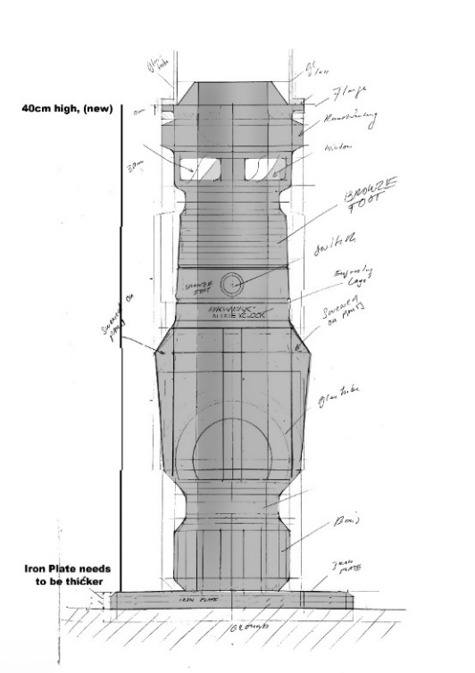

Dalibor Farny
Dalibor Farny stands as a unique force in crafting Nixie tube lamps, fusing vintage aesthetics with modern innovation. With an artisan's touch, Farny's lamps become functional art pieces, meticulously designed and personalized. Notably, the company's collaboration with NASA underscores its reliability in space-grade applications. Dalibor Farny's expertise and commitment to quality shine through each handmade creation, showcasing a blend of traditional craftsmanship and cutting-edge technology.

URWERK
URWERK appeared on the watchmaking scene in 1997, and since then has been shaking up the world of haute horlogerie with its revolutionary vision of time. Rebellious and unconventional, URWERK may be a young company, but it is a pioneer in the independent watchmaking landscape. Producing 150 pieces a year, URWERK is a house of craftsmen where watchmaking expertise and avant-garde aesthetics coexist in the best of all worlds. URWERK designs complex, contemporary timepieces that meet the most demanding criteria of Haute Horlogerie: independent research and creation; cutting-edge materials; hand-finishing.

Media contact.
Ms Yacine Sar
press@urwerk.com
+41 22 900 2027
www.urwerk.com/press

