URWERK – the UR-100V appears in a Full Titanium Jacket

Dubaï, November 25th, 2021.
The UR-100V saga continues with a new addition to the collection, the UR-100V Full Titanium Jacket: a single-colour version featuring different shades of grey, from Payne grey to lead grey. This limited-edition UR-100V is enhanced by a custom-designed metal bracelet.

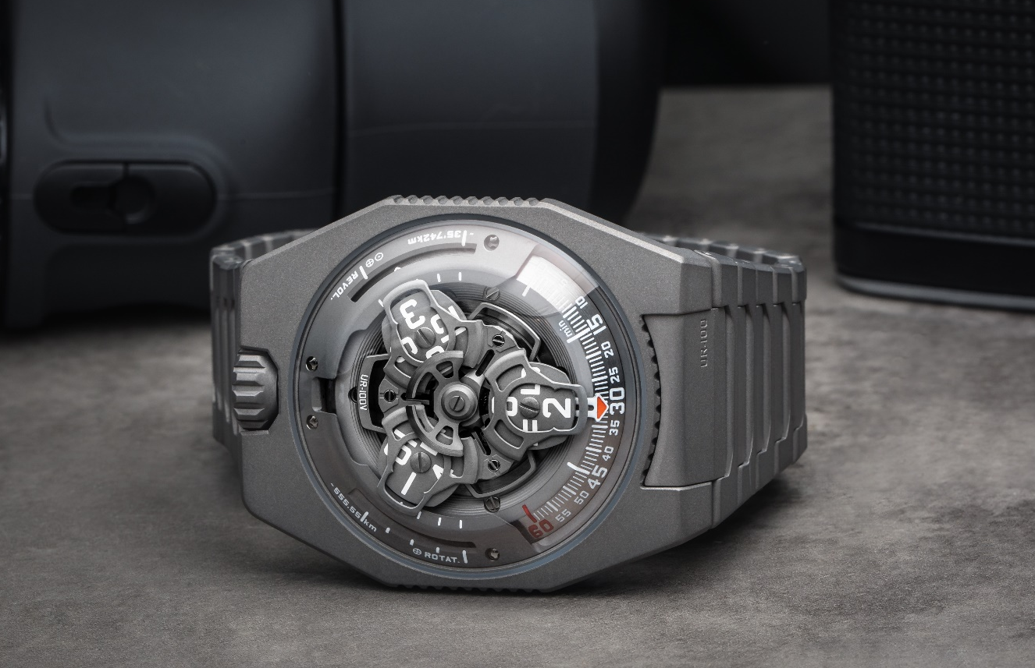

"With the UR-100V Full Titanium Jacket, I am once again fulfilling a dream of mine. From my first sketches for URWERK until the present day, I have always envisioned and designed our creations on a metal bracelet. The latter is an extension of the watch around the wrist and in my mind, it complements the design perfectly. I like the fact that the material – in this this instance titanium – is quite cold when you put it on your wrist. It warms up slowly on contact, acclimatising to you and gently embracing your skin. This extremely light bracelet also makes a special sound when you play with its links. It feels good. It is beautiful. To me, this watch is a real success and I am happy to see it come to life for real”, said Martin Frei, artist and co-founder of URWERK.

This very special bracelet is composed of 32 sandblasted titanium links ensuring a perfect aesthetic result.

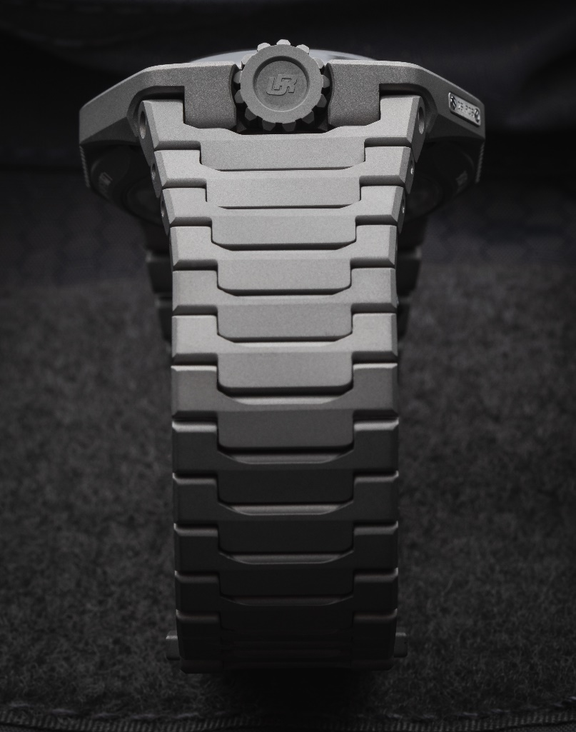

"Our goal was to make the most comfortable watch to wear. The UR-100V Full Titanium Jacket is a perfectly ergonomic watch. Its bracelet is ultra-light and incredibly soft against the skin. It’s a bracelet synonymous with pleasure," added URWERK co-founder and master-watchmaker Felix Baumgartner.

Under the UR-100V’s dome, in addition to URWERK’s trademark satellite configuration of the wandering hours and minutes, the UR-100V Full Titanium Jacket brings your spin through space into sharp focus. When the minutes hand has completed its 60-minute journey, it reappears on a 20-minute scale of 555 kilometres. This is the distance you travel in 20 minutes if you are standing on the equator of our rotating planet. The opposite scale tracks your journey through space around the sun: 35,740km every 20 minutes.

In the display on the UR-100V Full Titanium Jacket, time and distance are on a par, the hours and minutes in blue, and the kilometres in bright white. Watchmaker and URWERK’s co-founder, Felix Baumgartner, reveals that he got the idea from a clock given to him by his father, Geri, a noted restorer of antique clocks. “It was made by Gustave Sandoz for the Universal Exhibition of 1893. Instead of showing the time, it showed the distance travelled by a point on the equator.”

URWERK’s new calibre 12.02 drives the carousel carrying the wandering hours on three satellites. Felix Baumgartner says: “This movement enabled a redesign of the carousel, bringing the hours closer to the minutes as they travel in succession along the 60-minute scale. The result is an easier and more intuitive reading of the time”. This carousel, as well as the structure on top of the hours, are forged from anodised aluminium then sanded and shot-blasted, while the satellite screws are each circular sanded. The satellites rest on a carousel of sanded brass plated in ruthenium. The structure on top of the hours display is in sanded and shot-blasted aluminium. The selfwinding rotor of the UR-100 is governed by a profiled airscrew known as the Windfänger.

There’s a nostalgic look about the case of the UR-100V Full Titanium Jacket. Many owners of URWERK watches will recall the independent brand’s first models. “We have adopted some of the stylistic features of our first constructions, and then deconstructed them,” explains Martin Frei. “For example, the steel dome of our early models is now in transparent sapphire crystal. The hard outlines of the titanium and steel case highlight its perfection. Because I’m always at odds with the dictates of symmetry, I have used different proportions to catch the eye,” he concludes.

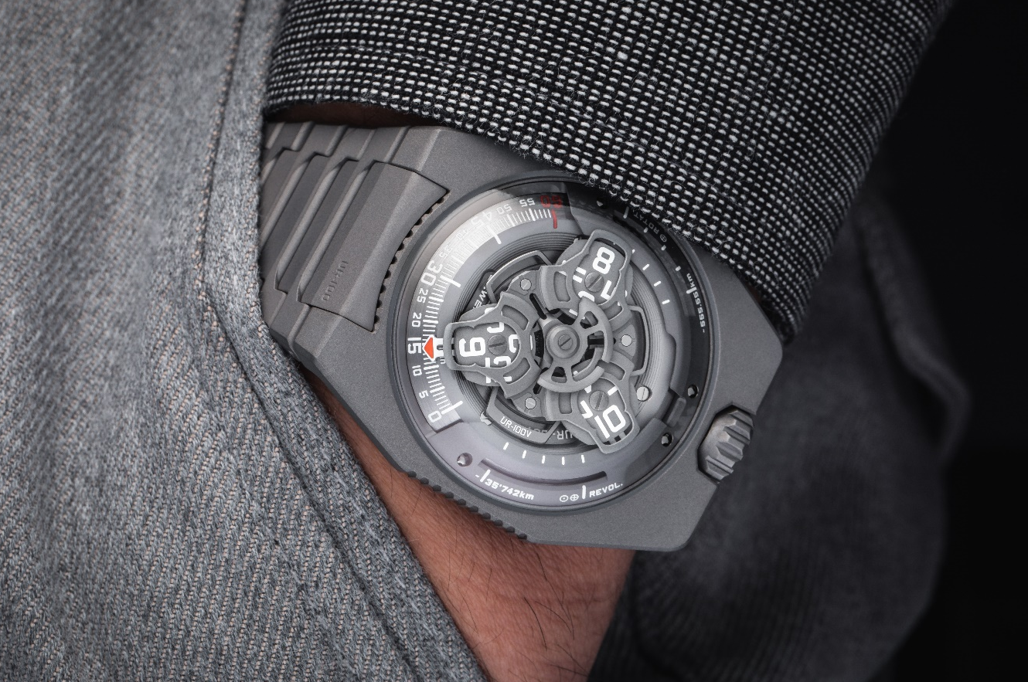
UR-100V Full Titanium Jacket – Edition limitée

Movement
Calibre | Selfwinding UR 12.02 movement with the winding rotor governed by a Windfänger airscrew.
Jewels | 40
Balance frequency | 28 800v/h - 4Hz
Power reserve | 48 hours
Materials | Satellite hours on beryllium-bronze Geneva crosses; aluminium carousel; carousel and triple baseplates in ARCAP alloy
Finishes | Circular graining and sanding shot peening; chamfered screw heads; hours and minutes painted in SuperLumiNova
Indications | Satellite hours and minutes; rotational distance at the equator in 20 minutes; orbital distance in 20 minutes
Case
Materials | Titanium
Dimensions | Width: 41mm, length: 49.7mm, height: 14mm
Glass | Sapphire crystal
Water resistance | Pressure tested at 3ATM (30m)
Bracelet | Titanium with 32 sandblasted links
Price | CHF 55'000.00 (Swiss francs / tax not included)

Contact: Ms Yacine Sar
press@urwerk.com
www.urwerk.com
+41 22 900 20 27

