URWERK – the UR-100V appears
in a Full Black Titanium Jacket

Geneva, June 15, 2022.
"Black is black. It's been our signature since day 01 of URWERK and it always will be. Our newest creation, the UR-100V Full Black Titanium Jacket is plain yet brimming with life and adrenaline. When a piece is dressed in black, it has to deliver its message straight to the heart. It has to be striking, intense. That's what we wanted to do here. The beauty of UR-100V in its raw, pure state.”
Felix Baumgartner and Martin Frei, co-founders of URWERK.

The UR-100V Full Black Titanium Jacket // 25-piece limited edition.
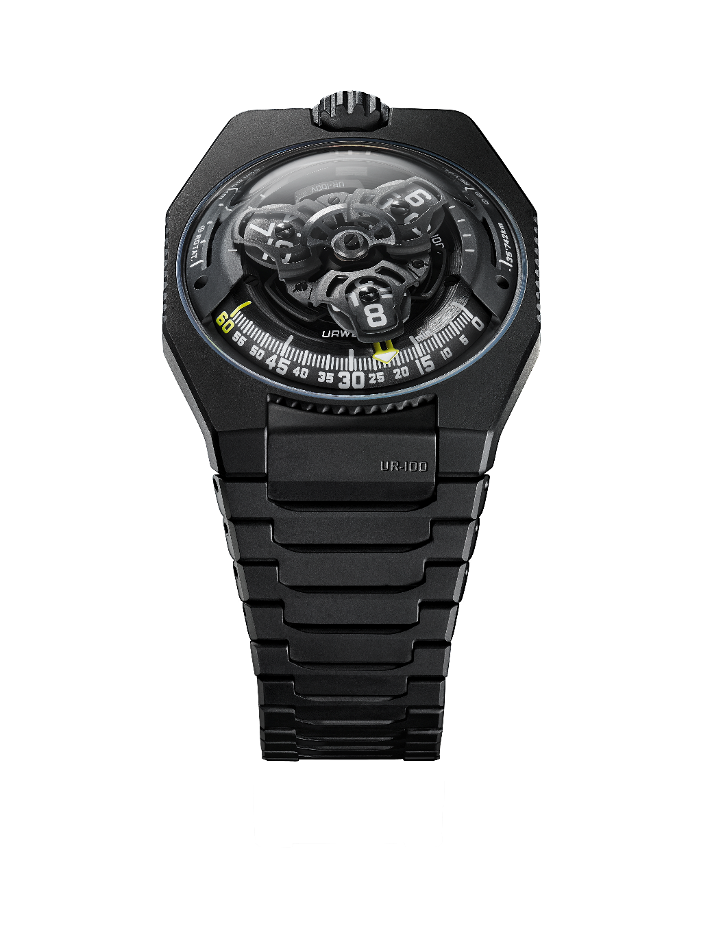

" From my first sketches for URWERK until the present day, I have always envisioned and designed our creations on a metal bracelet. The latter is an extension of the watch around the wrist and in my mind, it complements the design perfectly. I like the fact that the material – in this this instance titanium – is quite cold when you put it on your wrist. It warms up slowly on contact, acclimatising to you and gently embracing your skin. This extremely light bracelet also makes a special sound when you play with its links. It feels good. It is beautiful. To me, this watch is a real success and I am happy to see it come to life for real”, said Martin Frei, artist and co-founder of URWERK.

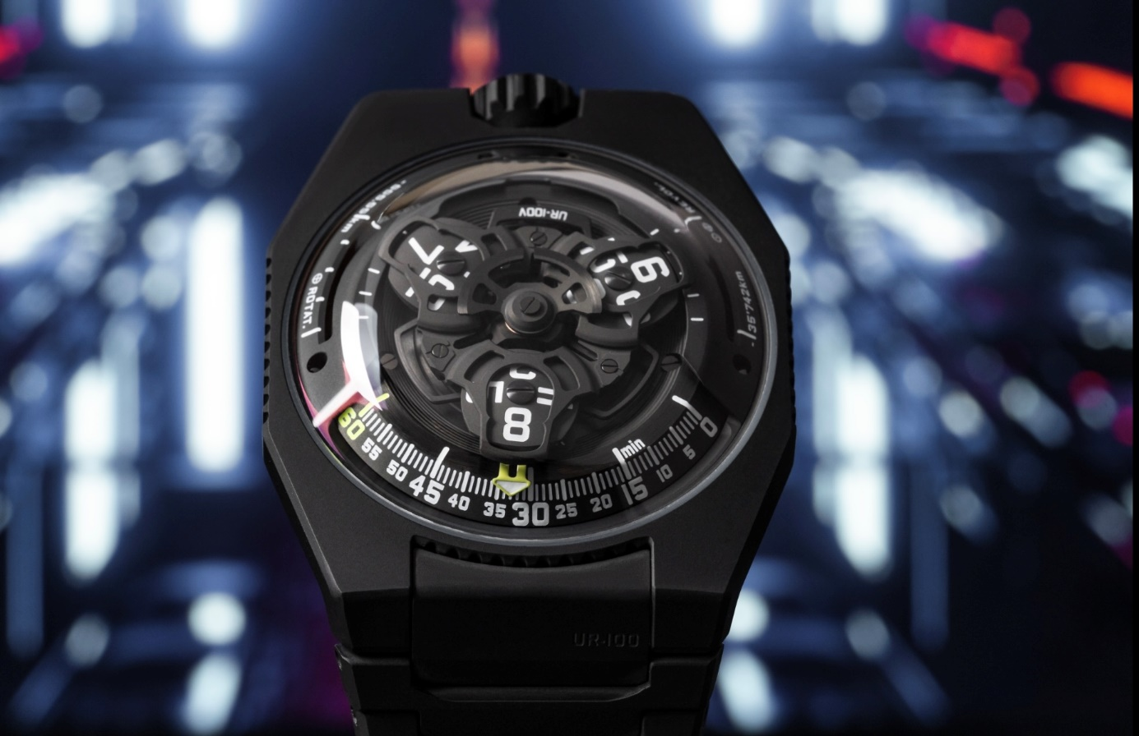

This very special bracelet is composed of 32 black DLC-treated sandblasted titanium links ensuring a perfect aesthetic result.

"Our goal was to make the most comfortable watch to wear. The UR-100V Full Black Titanium Jacket is a perfectly ergonomic watch. Its bracelet is ultra-light and incredibly soft against the skin. It’s a bracelet synonymous with pleasure”, added URWERK co-founder and master-watchmaker Felix Baumgartner.

Under the UR-100V’s dome, in addition to URWERK’s trademark satellite configuration of the wandering hours and minutes, the UR-100V Full Black Titanium Jacket brings your spin through space into sharp focus. When the minutes hand has completed its 60-minute journey, it reappears on a 20-minute scale of 555 kilometres. This is the distance you travel in 20 minutes if you are standing on the equator of our rotating planet. The opposite scale tracks your journey through space around the sun: 35,740km every 20 minutes.

In the display on the UR-100V Full Black Titanium Jacket, time and distance are on a par, the hours and minutes in blue, and the kilometres in bright white. Watchmaker and URWERK’s co-founder, Felix Baumgartner, reveals that he got the idea from a clock given to him by his father, Geri, a noted restorer of antique clocks. “It was made by Gustave Sandoz for the Universal Exhibition of 1893. Instead of showing the time, it showed the distance travelled by a point on the equator.”

URWERK’s new Calibre 12.02 drives the carousel carrying the wandering hours on three satellites. Felix Baumgartner says: “This movement enabled a redesign of the carousel, bringing the hours closer to the minutes as they travel in succession along the 60-minute scale. The result is an easier and more intuitive reading of the time.” This carousel, as well as the structure on top of the hours, are forged from anodised aluminium then sanded and shot-blasted, while the satellite screws are each circular sanded. The satellites rest on a sanded brass-plated ruthenium carousel . The structure on top of the hours display is in sanded and shot-blasted aluminium. The selfwinding rotor of the UR-100 is governed by a profiled airscrew known as the Windfänger.

There’s a nostalgic look about the case of the UR-100V Full Black Titanium Jacket. Many owners of URWERK watches will recall the independent brand’s first models. “We have adopted some of the stylistic features of our first constructions, and then deconstructed them”, explains Martin Frei. “For example, the steel dome of our early models is now in transparent sapphire crystal. The hard outlines of the titanium and steel case highlight its perfection. Because I’m always at odds with the dictates of symmetry, I have used different proportions to catch the eye”, he concludes.

UR-100V Full Black Titanium Jacket
Limited edition of 25

Movement
Calibre | Selfwinding UR 12.02 movement with the winding rotor governed by a Windfänger airscrew.
Jewels | 40
Balance frequency | 28,800 v/h - 4Hz
Power reserve | 48 hours
Materials | Satellite hours on beryllium-bronze Geneva crosses; aluminium carousel; carousel and triple baseplates in ARCAP alloy
Finishes | Circular graining, sanding, shot-blasting; chamfered screw heads; hours and minutes painted in Super-LumiNova®
Indications | Satellite hours and minutes; rotational distance at the equator in 20 minutes; orbital distance in 20 minutes
Case
Materials | Black DLC on shot-blasted and sanded crown;  Matt sanded logo;  Black DLC on sanded crown guard;  Caseband in black DLC on titanium case.  Caseback in black DLC-treated DLC sanded titanium
Dimensions | Width: 41mm, length: 49.7mm, thickness: 14mm
Glass | Sapphire crystal
Water resistance | Pressure tested at 3ATM (30m)
Bracelets | Titanium with 32 black-treated sandblasted links  (delivered with an extra rubber strap)
Price | CHF 65,000 (Swiss francs / excluding tax)
___________________

Contact: Ms Yacine Sar
press@urwerk.com
https://www.urwerk.com/press/ur-100v-full-black-titanium-jacket
+41 22 900 20 27

