URWERK’s UR-100 V Iron: bare and brilliant

Geneva, November 11, 2020.
URWERK has added a new watch to its UR-100 series. The UR-100V Iron comes cased in steel and titanium, monochrome and unadorned, to highlight its most delicate finish — all done by hand. No colours here but subtlety. Form and finish together create an ever-changing chiaroscuro over polished, matt, sanded and shot-peened surfaces.
Here is the UR-100V Iron!

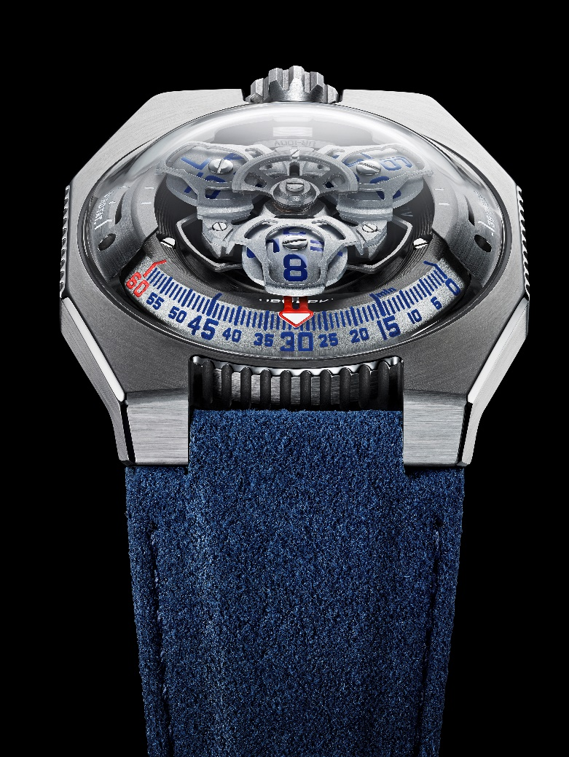

“The main reason to fall in love with a watch is an emotional reaction to its looks,” declares Martin Frei, URWERK’s chief designer and co-founder. “Beyond the complexity of its mechanism we have tried to refine this watch as much as possible. The UR-100V Iron appears in all its naked glory, leaving only the light reflecting on the metal to reveal its beauty.”

In addition to URWERK’s trademark satellite configuration of the wandering hours and minutes, the UR-100V Iron brings your spin through space into sharp focus. When the minutes hand has completed its 60-minute journey, it reappears on a 20-minute scale of 555 kilometres. This is the distance you travel in 20 minutes if you are standing on the equator of our rotating planet. The opposite scale tracks your journey through space around the sun: 35,740km every 20 minutes.
In the display on the UR-100V Iron, time and distance are on a par, the hours and minutes in blue, and the kilometres in bright white. Watchmaker and URWERK’s co-founder, Felix Baumgartner, reveals that he got the idea from a clock given to him by his father, Geri, a noted restorer of antique clocks. “It was made by Gustave Sandoz for the Universal Exhibition of 1893. Instead of showing the time, it showed the distance travelled by a point on the equator.”

Under the UR-100’s dome, URWERK’s new calibre 12.02 drives the carousel carrying the wandering hours on three satellites. Felix Baumgartner says : “This new movement enabled a redesign of the carousel, bringing the hours closer to the minutes as they travel in succession along the 60-minute scale. The result is an easier and more intuitive reading of the time”. This carousel, as well as the structure on top of the hours, are forged from anodised aluminium then sanded and shot-blasted, while the satellite screws are each circular sanded. The satellites rest on a carousel of sanded brass plated in ruthenium. The structure on top of the hours display is in sanded and shot-blasted aluminium. The selfwinding rotor of the UR-100 is governed by a profiled airscrew known as the Windfänger.

There’s a nostalgic look about the case of the UR-100V Iron. Many owners of URWERK watches will recall the independent brand’s first models. “We have adopted some of the stylistic features of our first constructions, and then deconstructed them,” explains Martin Frei. “For example, the steel dome of our early models is now in transparent sapphire crystal. The hard outlines of the titanium and steel case highlight its perfection. Because I’m always at odds with the dictates of symmetry, I have used different proportions to catch the eye,” he concludes.
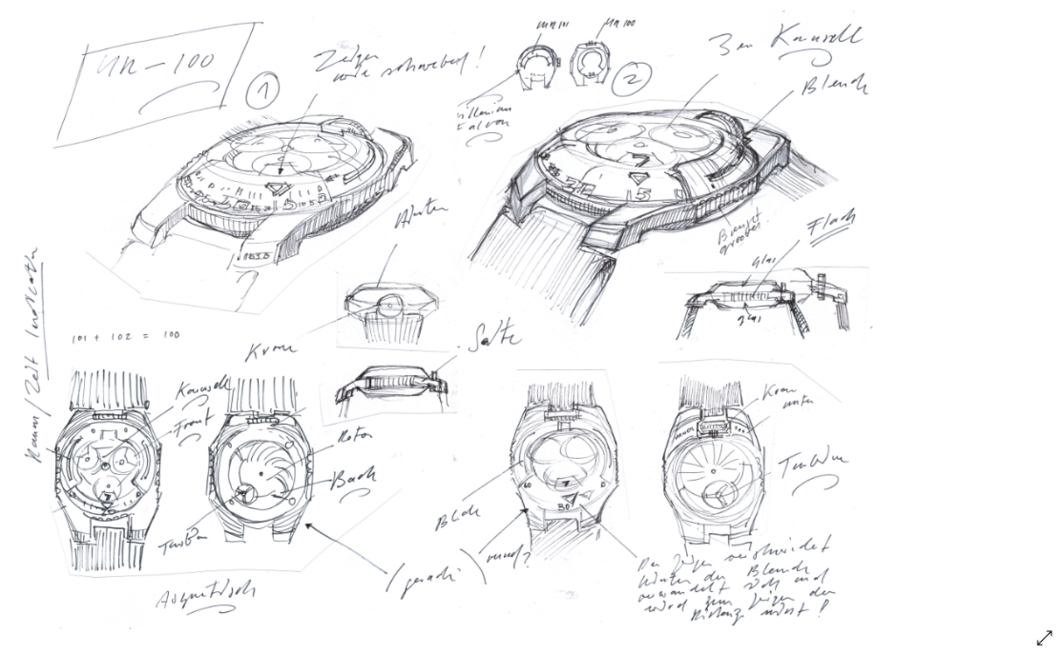

UR-100V Iron – Limited edition of 25
Movement
Calibre | Selfwinding UR 12.02 movement with the winding rotor governed by a Windfänger airscrew.
Jewels | 40
Balance frequency | 28 800v/h - 4Hz
Power reserve | 48 hours
Materials | Satellite hours on beryllium-bronze Geneva crosses; aluminium carousel; carousel and triple baseplates in ARCAP alloy.
Finishes | Circular graining and sanding, shot peening; chamfered screw heads; hours and minutes painted in SuperLumiNova.
Indications | Satellite hours and minutes; rotational distance at the equator in 20 minutes; orbital distance in 20 minutes.
Case
Materials | Titanium and stainless steel.
Dimensions | Width: 41mm, length: 49.7mm, height: 14mm
Glass | Sapphire crystal
Water resistance | Pressure tested at 3ATM (30m)
Strap | Blue Alacantra with a titanium buckle.
 | Price CHF 48,000.00 (Swiss francs / tax not included)

Contact :
Ms Yacine Sar
+41 22 9002027
press@urwerk.com

