URWERK MAKES A DRAMATIC ‘BACK TO THE FUTURE’ MOVE WITH THE UR-102 “RELOADED”,

Geneva, 22 March 2023.
This is doubtless the most eagerly anticipated URWERK collection. It is not, however, the most complex, nor the most singular. But it is the one that seals the beginning of the adventure, the starting point. A round URWERK watch … – yet hands-free, the only focal point being an hour unit gliding along a semi-circular track.
The 102 collection launched at Baselworld 1997 has not aged a bit. After a few adjustments to blend in with the times, the UR-102 "reloaded" is now presented in a boxed set containing its two versions: one in titanium, the other in signature URWERK black.

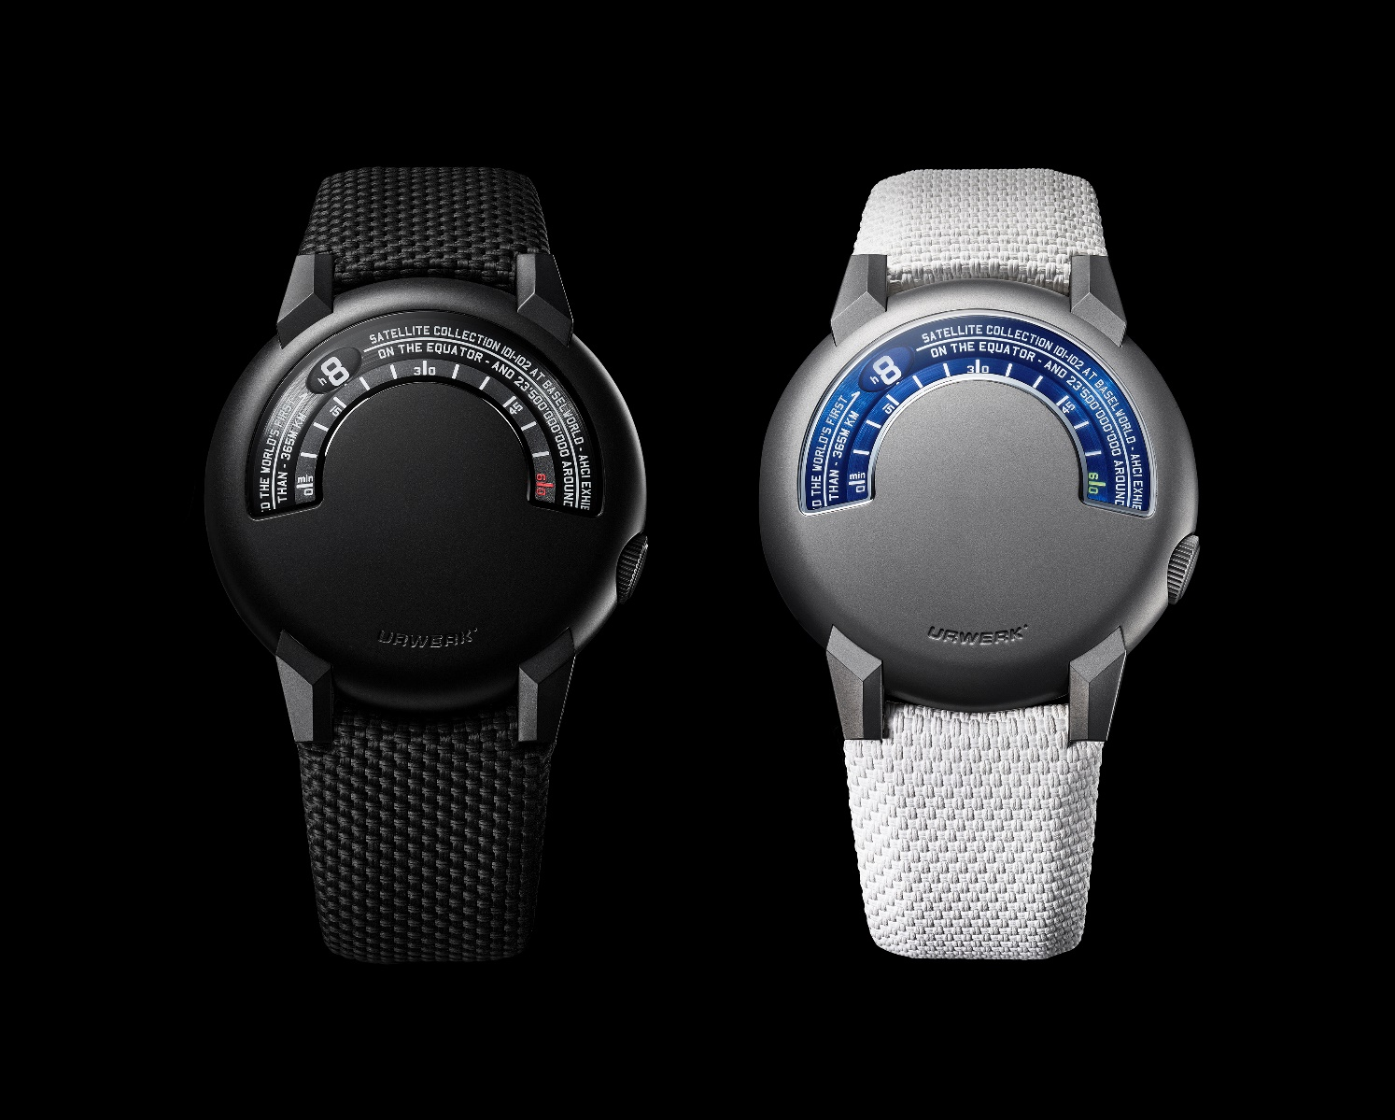

"The UR-102 is more than a symbol”, says Felix Baumgartner, master watchmaker and co-founder of URWERK. "It represents my entry into the AHCI (Académie Horlogère des Créateurs Indépendants). It embodies the first collaboration with Martin Frei, our first steps into the world of fine watchmaking, our first dreams of independence.”

The UR-102 is now back on the URWERK watchmaking benches in the form of the UR-102 "reloaded". In over two decades, this watch has grown in strength and size. It is now a respectable 41 mm in diameter compared to the 38 mm of its original version. Its size may have changed, but it remains as visually pleasing as ever. Its crown now merges into the case, having made a strategic move to 4 o'clock. Its lugs are larger, recalling the attachments on the Sputnik space satellite: solid, angular and designed to ideally position the "machine" on the wrist. The font of the hours and minutes markers has been redesigned, with new information appearing on the dial. UR-102 "reloaded" thus embodies a smoothly nuanced revolution.

Above all, this model set itself apart by its clean-cut design and innovation: "Right the very beginning, we had the deep and intimate conviction that focusing on the wandering hour was our path”, says Martin Frei, artistic director and co-founder of URWERK. "In my sketchbook, I started to draft a few designs. These served as a basis for our work. We were more than just enthusiastic, we were euphoric”, he recalls. "For this UR-102, our concept featured a time indicator that looked like a celestial body. It picked up the vibe of Sputnik, the first man-made artificial satellite. The satellite trajectory of our hours pointer followed a semi-circle from minute 0 (ascension) to minute 30 (the firmament) and disappeared at minute 60 (descent). Like Sputnik, the 'body' of our UR-102 was made of a shiny metal offering a mirror-like reflection of any bodies that might cross its path.

The UR-102 “reloaded” has retained this reflective power and the key characteristics of the UR-102. Felix Baumgartner says: "The blue of the original UR-102 is a distinctive feature we wanted to keep. At the time we wanted our design to be colourful and were thinking of a flame-blued shade for our case. So we used a lovely bright, intense, anodised aluminium. If you observe our UR-102 "reloaded" in its titanium version, you will notice that the minutes track is the same blue. It is these scattered clues that make the pedigree of the UR-102 "reloaded" patently clear. The same goes for the crown of the UR-102 "reloaded". "We redesigned and shifted the crown slightly. The migration of the crown led to a change in the opening for reading the time. No longer a perfect semi-circle, this ‘window’ is wider with sloping edges, giving it a fresher, more dynamic look", adds Martin Frei.

The UR-102 was born 26 years ago, the time it took for URWERK to travel 23,500,000,000 km around the sun. The journey continues!
The UR-102 "reloaded" is presented in a boxed set issued as a 25-piece limited edition and comprising the "Titanium" and "Black" versions.

Technical specifications
UR-102 “reloaded” presented in a boxed set (Titanium version and Black version) – 25-piece limited series – Price CHF 56,000 (Swiss francs / excl. tax)

Titanium version

Movement
Calibre | 2.02
Winding | Self-winding
Finish | Satin-brushed
Frequency | 28,800 vph
Jewels | 25
Power reserve | 48 hours
Indications | Wandering hours on satin-brushed and engraved discs  Hour- and minute- markers hand-painted with Super-LumiNova®
Case | Titanium case
Dimensions | Diameter: 41 mm; thickness 11.30 mm
Glass | Special-shaped sapphire crystal
Water resistance | Tested to 30 m (3 ATM)
Strap | Rubber strap with textured Baltimore-quilt pattern  Sandblasted and micro-blasted titanium pin buckle

Black version
Movement
Calibre | 2.02
Winding | Self-winding
Finish | Satin-brushed
Frequency | 28,800 vph
Jewels | 25
Power reserve | 48 hours
Indications | Wandering hours on satin-brushed and engraved discs  Hour- and minute- markers hand-painted with Super-LumiNova®
Case | Black PVD-treated steel, titanium caseback
Dimensions | Diameter: 41 mm; thickness 11.30 mm;
Glass | Special-shaped sapphire crystal
Water resistance | Tested to 30 m (3 ATM)
Strap | Textured rubber strap and Baltimora fabric  Sandblasted and micro-blasted black PVD-treated titanium pin buckle

