The URWERK UR-105 Tantalum Hull marks the end of the 105 Collection

Geneva - May 2021
“At URWERK we took radical decisions very early on: deciding to remain independent at all costs and limiting our growth despite all the advice to the contrary were among the most important. To continue staying true to ourselves, to remain URWERK, we make less than 150 pieces per year. This means that we reluctantly have to ‘kill’ a collection to bring a new creation to life. And time for the UR-105 CT is now running out,” explains URWERK co-founder Felix Baumgartner.
The new Tantalum Hull is the last edition of the UR-105 CT and ends the 105 collection in style.
Presenting the UR-105 TTH.

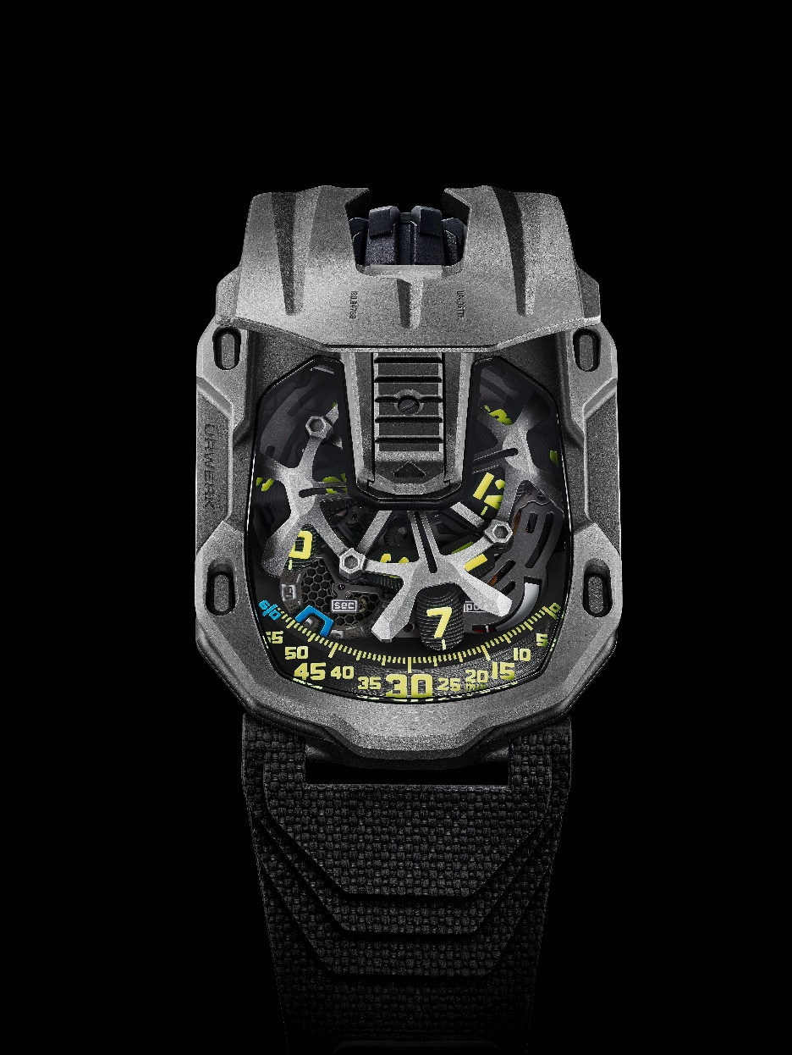

“Tantalum is a very special metal. Its name comes from Tantalus, one of Greek mythology’s bad boys. Tantalum is precious, rare, and extremely painful to machine and finish. We made an UR-110 out of tantalum a few years ago – a first that almost was the last. The team made me promise never to use it again because tantalum ‘eats’ our CNC machines’ bits. It destroys them, reducing their life by a factor of three. But I love its blue-gray luster. Pure magic!” co-founder Martin Frei discloses.

Fortunately, as so often with URWERK, desire won over reason. The UR-105 TTH is a limited edition of just 12 pieces. “Tantalum is a precious metal weighing approximately the same as platinum. It has a solid presence on the wrist. To machine it is a nightmare, but it has incomparable beauty. Tantalum is one of the most URWERK-ian metals I know of. It is dark, almost anthracite colored, a shade which is an integral part of URWERK’s aesthetic signature,” confides Felix Baumgartner.
The UR-105 TTH – “TTH” stands for Tantalum Hull – is a beautiful object, substantial and pleasing to hold. Its distinctive octagonal form features deep streaks along its entire length. It is angular, geometric, and symmetrical with strong influence from the Art Deco style.
Martin Frei explains, “The UR-105 TTH comes with a protective cover, a breastplate that protects the mechanism. Tantalum is a perfect protective shield against corrosion. Hence its name Tantalum Hull."

Activating the sliding “tongue” of the UR-105 TTH opens the hull to reveal its mechanics, featuring a satellite time indication built on a new skeleton carousel. The latter supports four hour satellites, each displaying three hour numerals that rotate in turn along the minute track, providing both analog and digital time displays.

A power reserve indication and digital seconds complete the information on the dial. The digital seconds displaying the seconds in ten-second increments is particularly remarkable. To make it as light and as ephemeral as possible, the seconds disk was made using the LIGA photolithography process and the marker is openworked. The total weight of the display is less than 0.10 grams.
On the back, two turbines regulate the movement’s automatic winding system, which can be easily adjusted using a small lever according to how active the wearer is. In the "FULL" position, the slightest movement of the wrist is enough to wind the mainspring. In “STOP” mode, the automatic winding system is deactivated and the UR-105 is manually wound. A third intermediate position, “RED” (for REDUCED), moderates winding to minimize excessive tension and wear.

UR-105 TTH (Tantalum Hull) -Limited edition 12 pieces
Technical specifications

Movement
Caliber: | UR 5.03, automatic winding regulated by twin turbines
Jewels: | 52
Frequency: | 28,800vph / 4Hz
Power reserve: | 48 hours
Materials: | Satellite hour Geneva crosses in beryllium bronze; skeletonized carrousel in aluminum; skeletonized nickel-phosphorus LIGA digital seconds; carrousel and triple mainplate in ARCAP
Finishing: | Perlage, bead blasting, frosting  Screw heads with polished bevels  Hours and minute indexes hand-painted with Super-LumiNova
Indications | Satellite hours; minutes, digital seconds  Power reserve
Case
Material: | UR-105 CT “soap bar” case in titanium and tantalum
Dimensions: | Width: 39.5 mm; length: 53mm; height: 17.8 mm
Crystal: | Sapphire crystal
Water resistance: | Pressure tested to 30 m / 3 ATM
Strap: | Vulcarbon© rubber reference “Kiska” with black DLC buckle
Price | CHF 77,000 (Swiss francs, excluding tax)

___________________

Contact press:
Mme Yacine Sar
press@urwerk.com
Tel +41 22 900 2027

ABOUT URWERK

“We don’t try to bring out new versions of existing grandes complications,” explains watchmaker Felix Baumgartner, co-founder of URWERK. “Our watches are unique because they are all designed as original works, which makes them rare and priceless. Our main aim is to go beyond the traditional horizons of watchmaking.” The original styling of each URWERK model is signed by chief designer Martin Frei, the company’s other co-founder. “I come from a background where creativeness has no limits. I am in no way prisoner of the traditional constraints of watchmaking, and I can therefore be freely inspired by my cultural heritage.”

Although URWERK is a young company established in 1997, it is recognised as a pioneer among independent watchmakers. Producing just 150 watches a year, the company sees itself as a craftsman’s studio where traditional expertise coexists with avant-garde styling. The company manufactures modern and complex watches that are unprecedented and in keeping with the most demanding criteria of fine watchmaking: independent design and research, advanced materials and handcrafted finishes.

The name URWERK comes from the ancient city of Ur of the Chaldees in Mesopotamia, founded nearly 6,000 years ago where the Sumerian inhabitants first established units of time based on the shadows cast by its monuments. Ur in the German language also means primeval or original and Werk means an achievement or a mechanism. Thus, URWERK can be translated as an original movement — a tribute to generations of watchmakers whose work has resulted in what we know today as haute horlogerie, or superlative watchmaking.

