URWERK UR-120 lost in Black Space

Genève – le 21 juin 2023.
URWERK proudly presents its new UR-120! This black cosmic creation fuses advanced technology, celestial inspiration, and a touch of science fiction, captivating horological enthusiasts across the galaxies.
Let’s dive into the UR-120 Space Black!
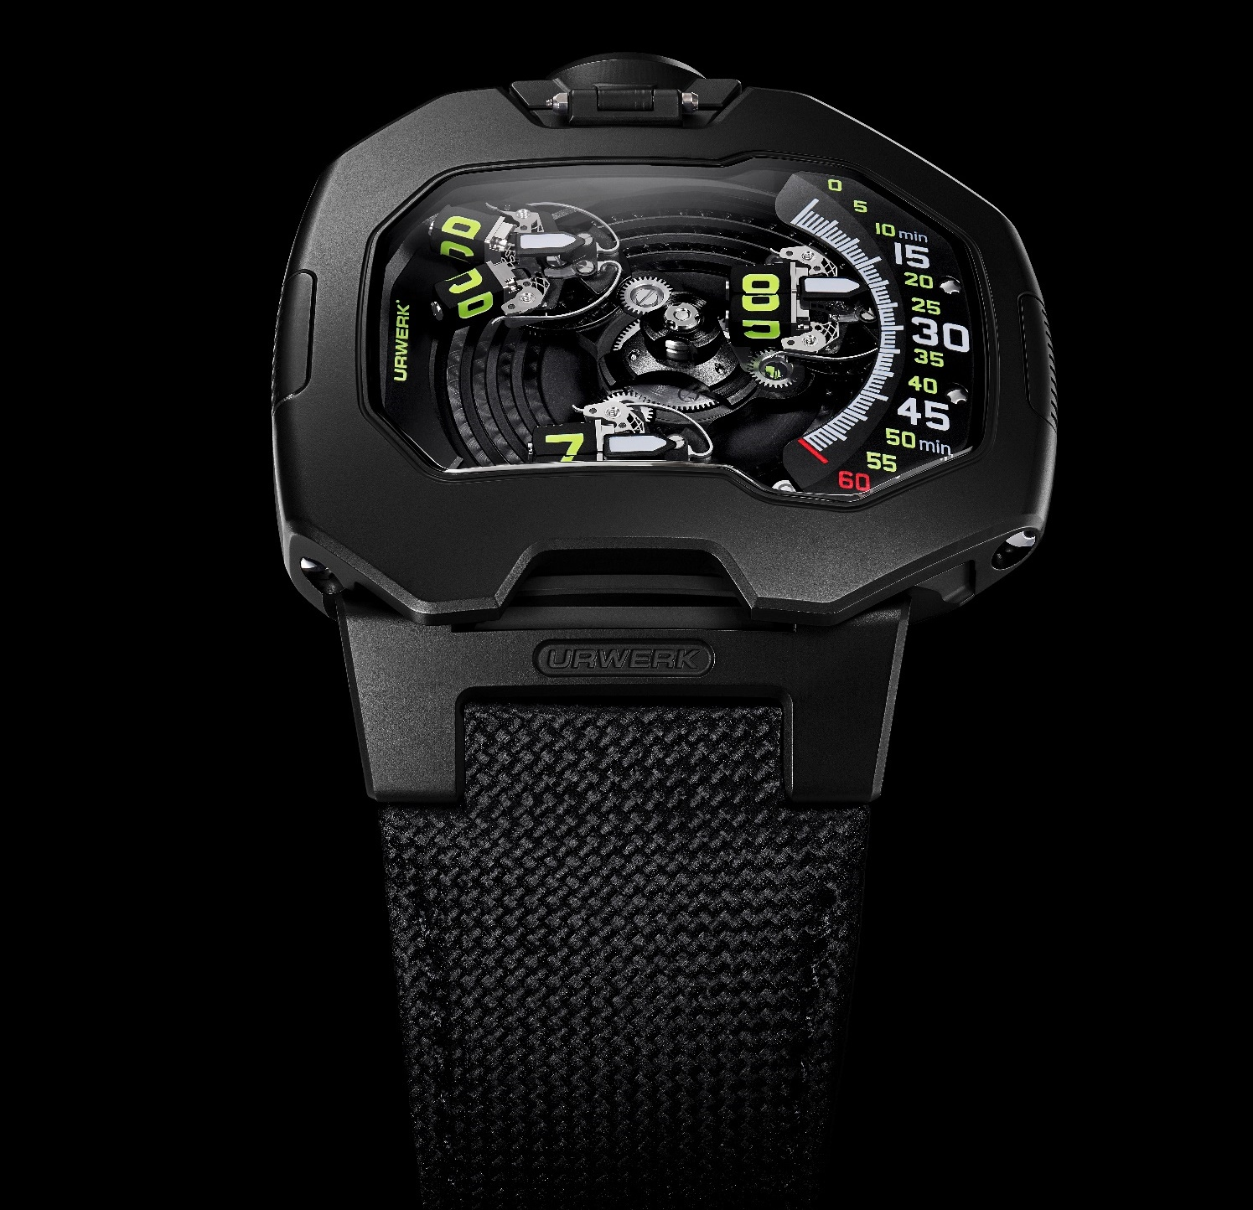
Martin Frei explains: “The UR-120 Space Black is all about the power of black in design. The use of black not only exudes elegance but also fundamentally transforms our perception of the object. Black works its magic by subtly distorting our judgments of size, while intensifying the watch's contours to create a truly mesmerizing effect.”
This UR-120 is a beautiful demonstration of ergonomic ingenuity, combining form and function in perfect harmony with its 44mm length, 47mm width, and 15.8mm thickness. With the upper part of the case seamlessly smooth, devoid of any screws, the UR-120 features a flawless silhouette.

To tell time, the UR-120 features a new revolving satellite complication: analog minutes and a never seen before split open digital hour satellite mounted on planetary gears. This particular hour satellite morphs into the form of a V-shaped open hand. This time indication rotates on its own axis, split open to unveil its secrets smoothly.
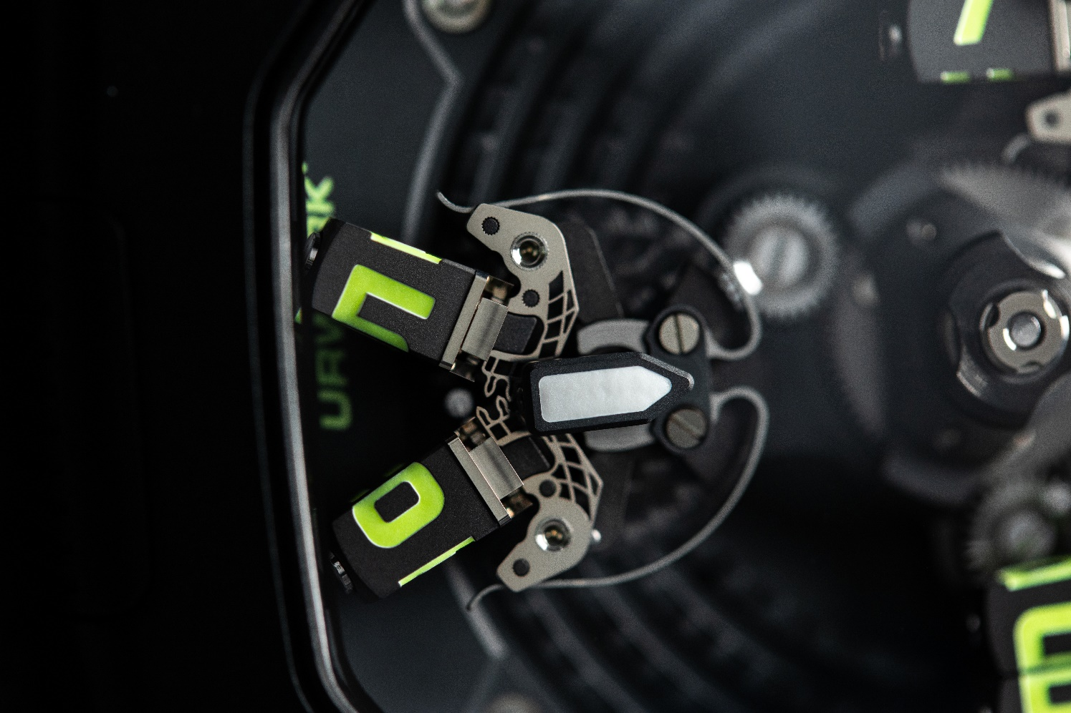
Powered by the caliber UR-20.01, the UR-120 harnesses the energy of the stars within its intricate mechanism. The central carousel, equipped with three arms, gracefully carries the satellites that bear the hour markers on all four sides. As the satellite traverses the minute track, it reaches the left part of the case, setting in motion a sequence of movements. The satellite splits open, revealing two rectangular studs. They take on a V-shape, reminiscent of the Vulcan salute. Once separated, both studs spin on their own axis and shut, all in order to display the new hour unit.

There is a triple revolution taking place under the hood of this spacecraft: the satellite-bearing carousel spins on a central axis, each satellite counter-spins in order to remain upright and therefore readable and each stud spins on its own axis.
Felix Baumgartner, co-founder and master watchmaker of URWERK, expresses his enthusiasm about the extraordinary challenges faced during the development of the UR-120: “On the part alone governing the partition of our satellite time, there are more than 175 components. These intricated parts meticulously crafted with our CNC machines, rock and roll with micron-level exactitude. This 'Vulcan salute' complication we dreamt of and created is synonymous with live long and prosper still it cost us a few hours of our lives and quite some stress, but the result is definitely worthy of our efforts. This achievement is nothing short of spectacular!"
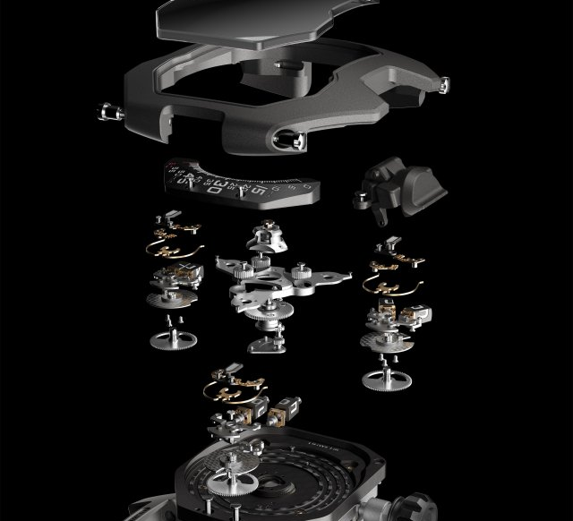
Technical Specifications:
UR-120 Space Black
Price: CHF 110’000.00 (Swiss francs / no tax included)

MOVEMENT
Caliber: | UR-20.01, self-winding
Escapement: | Swiss lever
Frequency: | 4 Hz; 28,800 vph
Power reserve: | 48 hours
Materials: | Beryllium-copper, grey PVD brass, black-PVD and black-rhodium, anodized aluminum, ARCAP, titanium, LIGA-processed nickel
Hand finishing: | Circular- and straight-graining, sandblasting, côtes de Genève, polished screw heads
CASE
Dimensions: | Width 47 mm; length 44 mm; thickness 15,8mm
Materials: | Sandblasted titanium, sandblasted steel bezel. Black DLC treatment and silicon (SI) coating
Crystal: | Curved sapphire crystal with anti-reflective treatment
Water resistance: | Pressure-tested to 3ATM / 30m / 100ft
STRAP  _______________________ | Black calf leather with embossed Cordura pattern
Media contact:
Ms Yacine Sar +41 22 900 2027
press@urwerk.com
www.urwerk.com/press

URWERK
“We don’t try to bring out new versions of existing grandes complications,” explains watchmaker Felix Baumgartner, co-founder of URWERK. “Our watches are unique because they are all designed as original work. Our main aim is to go beyond the traditional horizons of watchmaking.”
The original styling of each URWERK model is signed by chief designer Martin Frei, the company’s other co-founder. “I come from a background where creativeness has no limits. I am in no way prisoner of the traditional constraints of watchmaking, and I can therefore be freely inspired by my cultural heritage.”
Although URWERK is a young company established in 1997, it is recognised as a pioneer among independent watchmakers. Producing just 150 watches a year, the company sees itself as a craftsman’s studio where traditional expertise coexists with avant-garde styling. The company manufactures modern and complex watches that are unprecedented and in keeping with the most demanding criteria of fine watchmaking: independent design and research, advanced materials and handcrafted finishes.

The name URWERK comes from the ancient city of Ur of the Chaldees in Mesopotamia, founded nearly 6,000 years ago where the Sumerian inhabitants first established units of time based on the shadows cast by its monuments. Ur in the German language also means primeval or original and Werk means an achievement or a mechanism. Thus, URWERK can be translated as an original movement — a tribute to generations of watchmakers whose work has resulted in what we know today as Haute Horlogerie, or superlative watchmaking.

