UR-210S "Full Metal Jacket": The favorite child

Geneva – January 19, 2015
"I really don't think that I can do better," emotionally explains Martin Frei, artistic director and co-founder of URWERK, as he presents the latest addition to the URWERK collection. "In my eyes the UR-210S is our most accomplished creation to date."
Many already know the UR-210 for its orbital complication and imposing retrograde minute hand. However, this 'S' version – a limited edition of just 35 pieces – adds an even stronger monochrome aesthetic with its full metal bracelet, which was developed specifically for URWERK. The radical UR-210S is uncompromising – it will be love at first sight for aficionados of avant-garde horology.
Warning: The UR-210S is highly addictive.

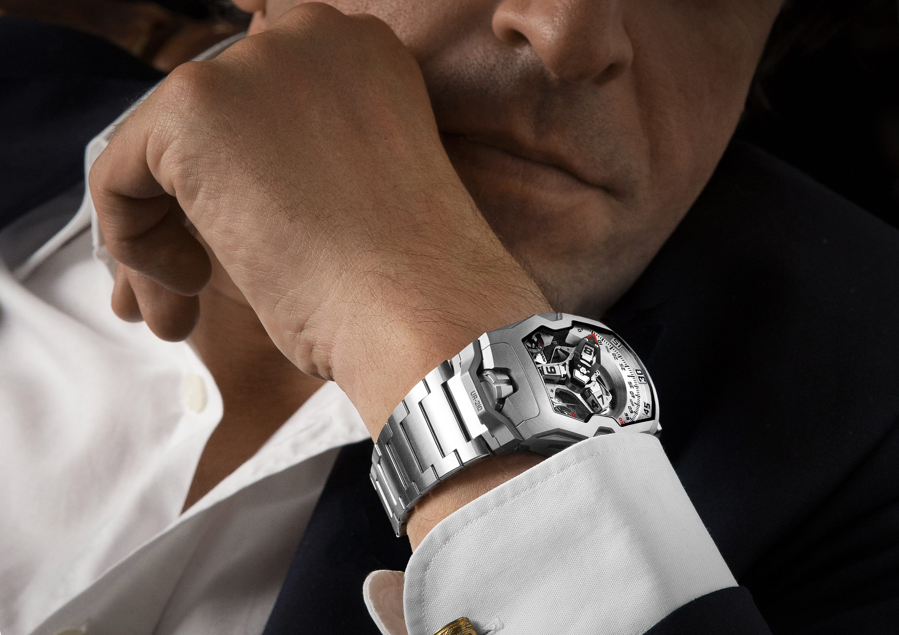
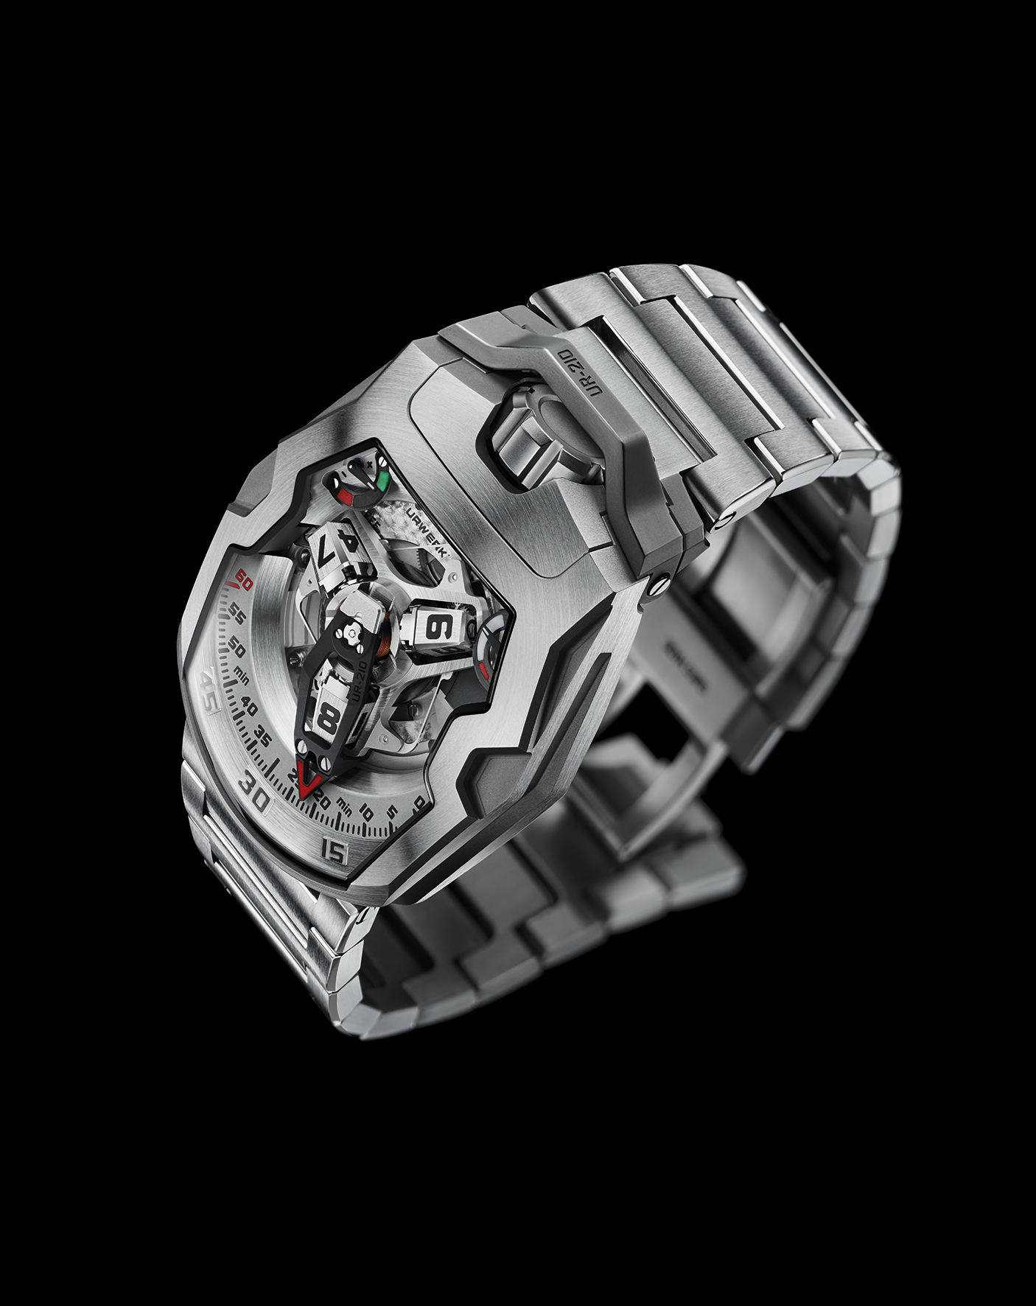

The UR-210’s satellite complication with retrograde minute is both highly original and totally explosive. The principal feature is a high-tech, oversized, three-dimensional retrograde minute hand. Its function is to enclose the hour satellite and indicate the time as it transverses the 0-to-60-minute scale. This one-hour journey through time, tracing an arc of 120°, is smooth and fluid. But the true nature of the piece is revealed at the end of the 59th minute. Then a sharp distinct “click” signals the return of the minute hand to its starting point. In less than 0.1 of a second the hand flies back to dock with the next hour satellite. This high-speed retrograde system is based on three key elements:
- A central axis set in ruby bearings provides excellent stability for the satellite/retrograde complication. A cylindrical marine chronometer type spring runs vertically around the axis and generates the optimal tension required for the retrograde minutes flyback.

- A minute hand, which also forms a frame for the hour satellites, displays the time in an extraordinary way. Milled from aluminum to exacting tolerances of approximately 3 microns, the whole structure has a total weight of just 0.302g and is counter balanced by a brass weight. This three-dimensional cage offers rigidity as it transfers energy from the cylindrical flyback spring in the top center of the carrousel to the double-star gear underneath.

- A double coaxial star-shaped cam regulates the retrograde mechanism through its gearing and its rotation defines the trajectory of the minute hand. When the minute hand reaches 60, the double star trips a (one of three) hockey stick shaped spring under the mechanism, which liberates the minute to fly back to the next hour satellite at 0-minutes.

The dial of the UR-210S features a traditional power reserve indication at one o’clock. In a near mirror image at 11 o’clock we find a similar indication. No, it isn’t a duplicate fail-safe, but something much more important which deserves our full attention, because it is actually a world-first complication that indicates winding efficiency over the last two hours.
Has your recent activity been enough to replenish your UR-210’s energy levels? If yes, the winding efficiency indicator will point emphatically to the green zone. If not, you have been using more energy than you are generating, and the winding efficiency indicator will point to the red zone.
Armed with knowledge of both winding efficiency and available power reserve, you are then able to intervene. If your UR-210 indicates an insufficient supply of energy, you can position the winding efficiency selector at the back of the watch to “FULL”.
The rotor will then convert the slightest movement into stored energy. In this configuration, a turbine connected to the rotor provides smooth, unimpeded power. But if you are more active, then that may provide more power than required and unnecessarily wear the mechanism. In that case, you would position the winding efficiency selector to “REDUCED” to engage the rotor damping system. An air turbine compressor mounted on ruby bearings ​​spins and creates internal resistance – enough friction to slow down or dampen the automatic winding rotor. In “STOP” mode, the automatic winding system is disabled completely and the UR-210 runs off reserve power and may require manual winding.

Media inquiries:
Ms Yacine Sar
E-mail : press@urwerk.com
T +41 229002027 M +41 79 834 4665

UR-210S “Full Metal Jacket ” – Technical Specifications

Case
Material | Titanium and steel
Dimensions | Width 43.8mm, length 53.6mm, thickness 17.8mm
Glasses | Sapphire crystal
Water resistance | 30m/100’/3ATM
Surface finishes  Strap: | Satin finish; bead-blasted  Metal bracelet with deployment clasp developed by Maspoli for URWERK

Movement
Caliber | UR-7.10
Jewels | 51
Escapement | Swiss lever
Balance | Monometallic
Frequency | 28,800v/h, 4Hz
Balance spring | Flat
Power source | Single mainspring barrel
Power reserve | 39 hours
Winding system | Self-winding coupled to turbines
Materials | Plate in ARCAP P40 rhodium coated; 3D minute hand in aluminum with brass counterweight; central cylindrical spiral in spring-steel; hour satellites in aluminum; central carrousel and screws in Titanium Grade 5
Surface finishes | Circular graining, sandblasted, circular and straight satin-finished plate; satin-finished and diamond-polished satellites; beveled and polished screw heads
Indications | Patented revolving satellite complication with wandering hour and three-dimensional retrograde minute hand; power reserve indicator; patented winding efficiency indicator  Super-LumiNova treatment on markers, dials, indexes, hands, and satellites
Controls | Two-position winding crown with crown protector  On the back: winding efficiency selector

