Emmanuel Esposito
and Johnny Dowell “King Nerd”:
original talent set free

Geneva – March 2019
They are young, but you can see from their work that they master their respective crafts. One creates extraordinary art knives; the other is an artistic engraver. Highly regarded in their own niche specialities, they now venture into the world of URWERK. Their playing field — the UR-T8.

But let them tell their own stories:

URWERK and Emmanuel Esposito
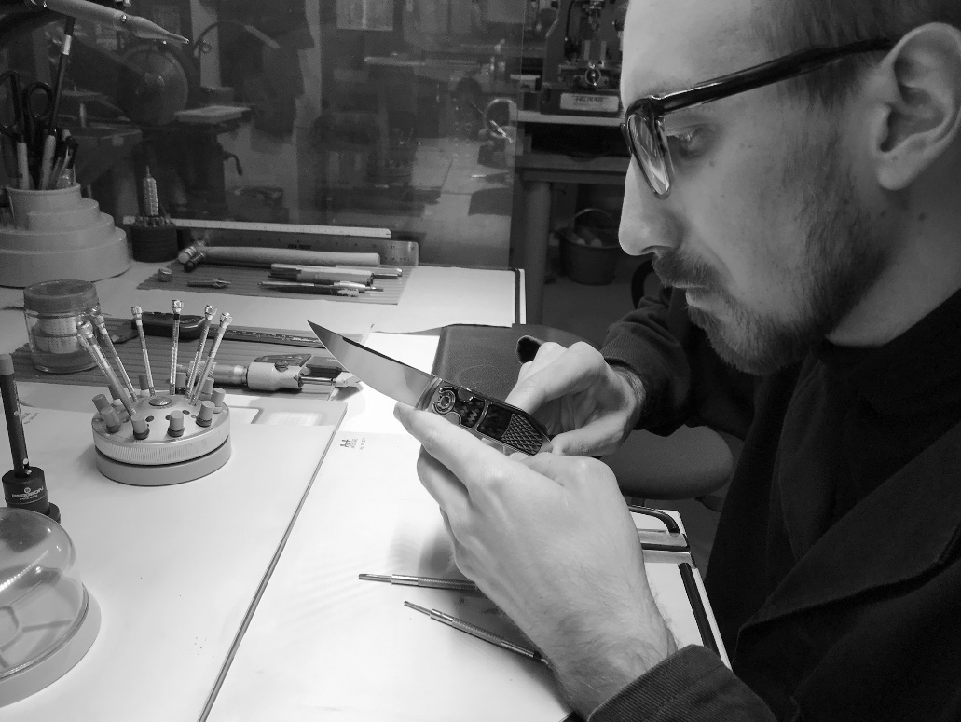

His name is Emmanuel Esposito. You will know him if you are a fan of bladed masterpieces — not those, of course, that will ever cut flesh — but the exquisite and collectible ones where the light plays along the metal. Today this craftsman is 36 years old. When he was 15, having already spent much of his childhood in his grandfather’s machine shop, he developed a fascination for finely crafted knives. He started by buying specialist magazines and going to trade fairs featuring knives. “My passion for knives started growing inside of me. I started making fixed blades, but soon moved on to integral and

eventually ended up making folders. Within few years, I became a member of the Italian Guild.” He developed his distinctive and unique style over the years, using high-tech material like carbon fibre and metal alloys along with traditional material like gold and mother of pearl. “I soon realized that old and new made a subtle and unexpected combination. It led to the distinctive look of my work.”

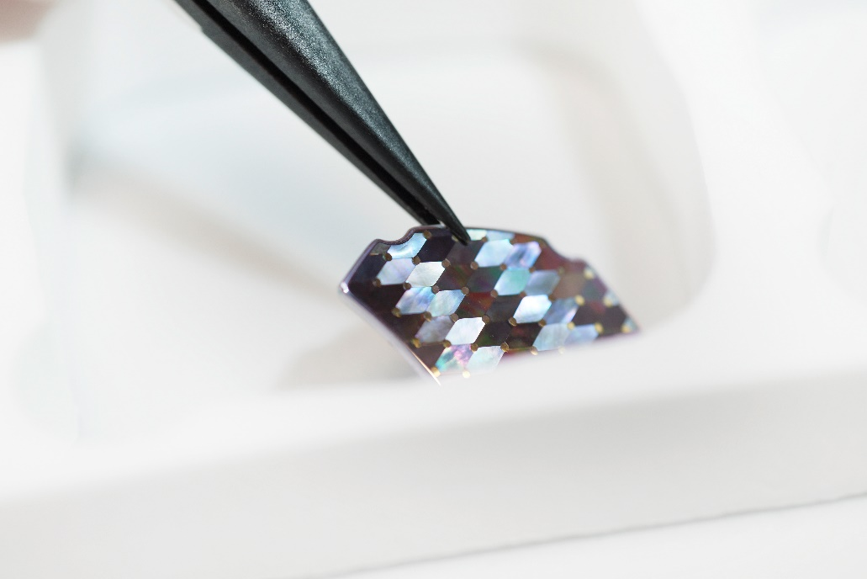

When URWERK approached him with an offer to work together, and showed him the UR-T8, he said yes unhesitatingly. “There was the ambition to do something really unique and the space to do it in.” He even set the bar higher to create a one-off matching knife for the watch. The UR-T8 “Colibri” watch will thus come with a T8 “Colibri” knife.

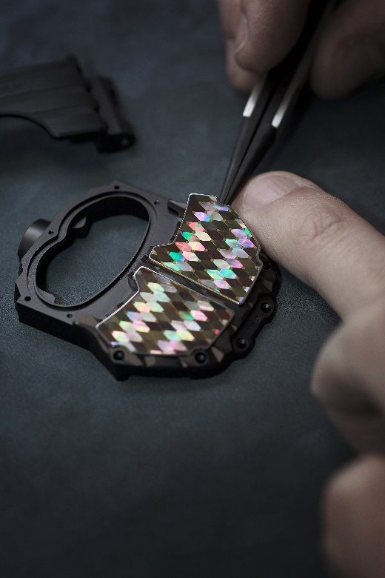

“The UR-T8 watch Colibri case features the same mosaic inlay technique used in the folding knife's inlays. Hundreds of individual pieces of black-lip mother of pearl were cut into diamond shapes then hand-sorted and arranged according to how each reflects the light. The resulting mosaic inlay oscillates between light and dark with movement. Pins in 18k gold accentuate each pearl intersection, and the two mosaic inlays are set into stainless steel frames and housed in the 3-D sculpted titanium watchcase.

The watch is paired with its art knife. The Colibri T-8 model is a customized folding knife. Its handle frame in 416 stainless steel encases a blade mechanism, which runs on ceramic ball bearings. The knife's handle, lock button and blade spine feature black lip mother of pearl mosaic inlays, designed with an alternating light technique, which creates a distinctive chromatic effect. Every piece of pearl is connected by individual 18k gold pins, and each mosaic inlay is outlined with a black vintage Bakelite frame. The diamond patterned mosaic inlay is paired with a titanium insert, 3-D sculpted with the same pattern as the URWERK T8 case. Additionally, the shape of the patented C-Lock mechanism, which locks the blade in both the open and closed positions, has been redesigned to resemble the outline of the URWERK T8 case. A very special attribute of this knife is the inclusion of a sapphire glass window which displays a kinetic internal turbine, similar to the working turbine in an Urwerk watch mechanism.”

The UR-T8 “Colibri and its T8 “Colibri” art knife – each a unique object.

URWERK and Johnny Dowell a.k.a “King Nerd”

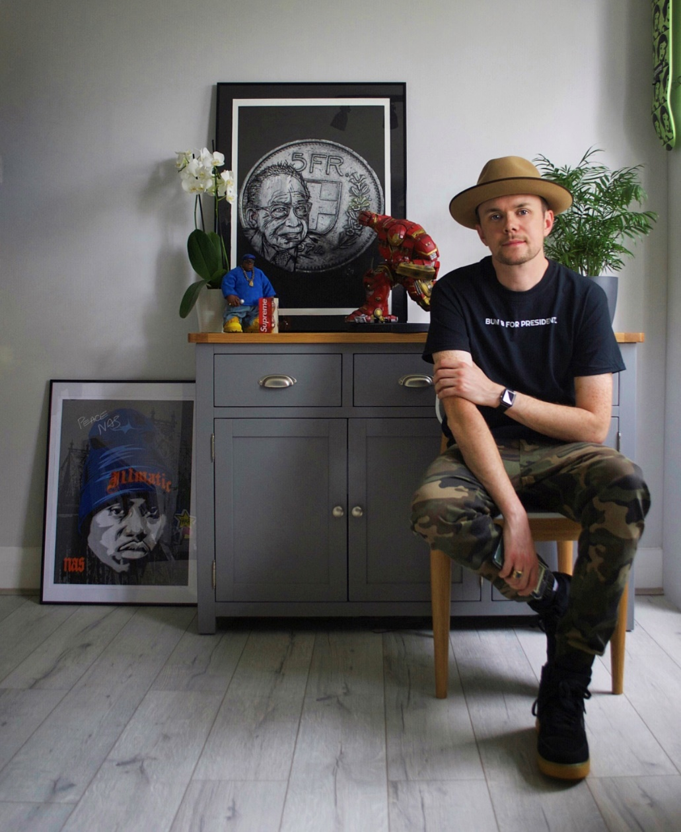

He’s an engraver, but started out sketching and painting on paper, displaying a creative talent that destined him for a top art academy. But his uncle, who worked for the London gunmaker, James Purdey & Sons, was to change his career. Young Johnny found a Purdey catalogue and was captivated. He joined the company as a gifted apprentice, the youngest ever enrolled. For 15 years, he learned how to engrave metal on sporting and collectors’ guns.
He later came across the world of watchmaking when a customer asked him to personalise a Reverso watch. It was his first venture into fine horology. “The transition was a strange one at first and I did have to adapt. The biggest difference is the size of the canvas – a watch case is obviously a lot smaller – but when you come down to the basics, it’s actually very similar. Both guns and watches are expensive products so there is a huge amount of pride in working on them. It has been an interesting change, but one I have welcomed with open arms.” His meeting with the legendary Wei Koh, the founder of the iconic Revolution magazine was to be decisive. Engraving watches became his obsession and his obsession became his job. “The process always starts out with sketches; you’ll find yourself going back and forth until the artwork fits perfectly in the desired space. I always cut all of the outlines of the artwork before doing the shading. The most important consideration for me is the material of the watch.”

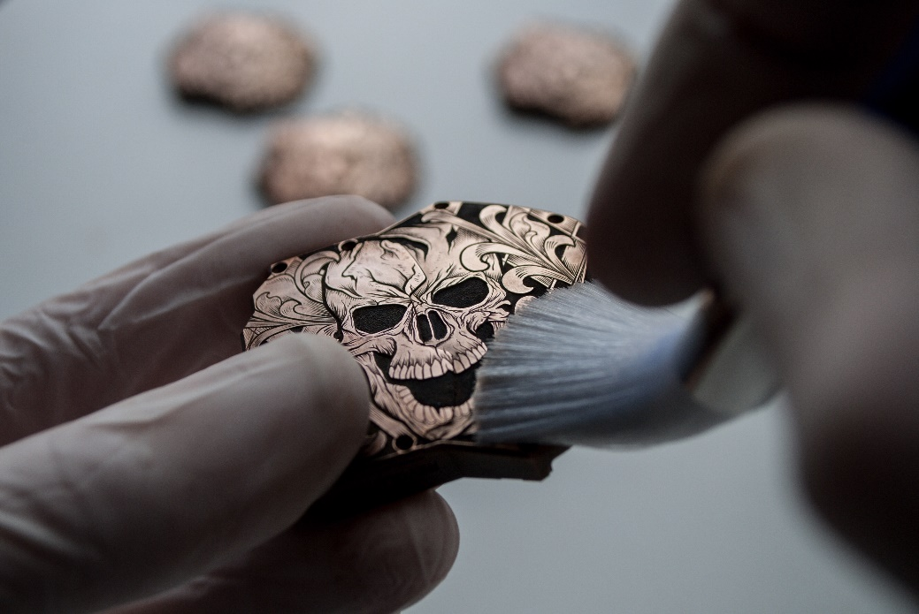

When he learned that he was to work on the UR-T8, he did not think twice. “I love the UR-T8. It’s one of my favourite URWERKs — what a canvas! I drew my design and chopped and changed scrolls until I loved it; I wanted to be able to say I would love to wear that myself.” The creative process was to take months. “After the design was ready I scaled everything down to the exact size of the UR-T8. The first thing I always do is cut every outline that includes the scrolls and skull. The next stage for me is the background. I carve everything away to the depth I feel works best. This the most time consuming part of the whole project for me, removing the background carefully under the microscope to make sure I don’t over run into the important parts such as the scroll areas or the skull. There is no going back if you make a mistake. Once this process is done, I get to do my favourite part, the shading.

When I do the shading, I briefly refer to the original design because the shading operation feels like I am drawing again. I incise the lines in the areas needed and slowly bring the whole piece together. I step back every now and then during this process to make sure I’m not overdoing the shading, and I keep doing this until I cut my final line. When everything is complete I begin the blacking process. This is the part that really makes the whole case pop! That black against the bronze colour works so nicely. I use different grades of polishing paper to get a finish I am happy with, and then there you have it — I’m finished and happy. Well not quite, that’s only the first case done. I still had another four to do and they all needed to match!”

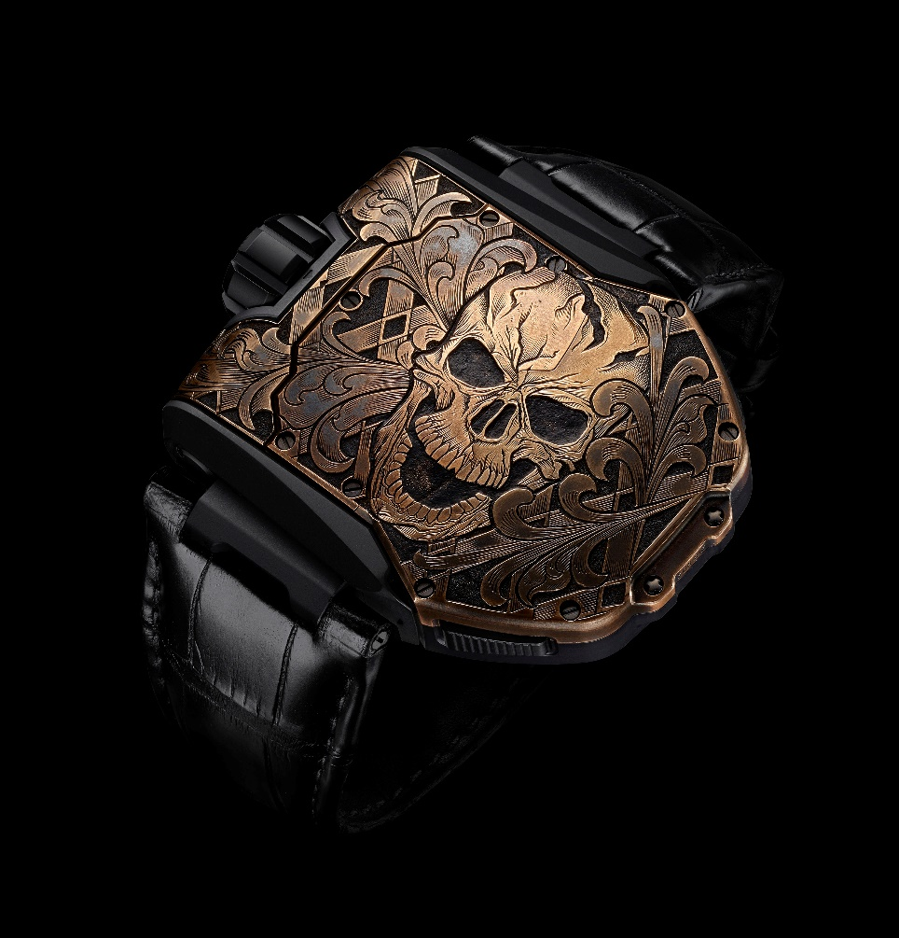

Technical specifications

The UR-T8 “Colibri” with its T8 “Colibri” art knife
Pièce unique

Movement
Calibre: Selfwinding UR 8.01
Balance: Monometallic
Frequency: 28,800v/h, 4Hz
Balance spring: Flat
Power: Single barrel
Power reserve: 48 hours
Winding system: Uni-directional rotor connected to a spinning vane
Finish: Brushed, circular grained and diamond-cuts

Indications
Satellite complication with rotating hour modules mounted on planetary gears

Case
Unique flip-over case in Grade 5 titanium set with black-lip mother of pearl
Dimensions: 60.23mm X 48.35mm X 20.02mm
Water resistance: 3 ATM

The “Colibri” T-8 art knive
Pièce unique

Customized folding knife with lock button and blade spine set with black lip mother of pearl mosaic
Handle frame in 416 stainless steel featuring a kinetic internal turbine
Blade mechanism running on ceramic ball bearings

The UR-T8 Skull
Special edition - limited to five watches
Price CHF 144’000.00 (Swiss francs / Tax not included)

Movement
Calibre: Selfwinding UR 8.01
Balance: Monometallic
Frequency: 28,800v/h, 4Hz
Balance spring: Flat
Power: Single barrel
Power reserve: 48 hours
Winding system: Uni-directional rotor connected to a spinning vane
Finish: Brushed, circular grained and diamond-cuts

Indications
Satellite complication with rotating hours modules mounted on planetary gears

Case
Flip-over case in Grade 5 titanium and bronze. Hand engraved
Dimensions: 60.23mm X 48.35mm X 20.02mm
Water resistance: 3 ATM

Media contact:
Ms Yacine Sar
Phone : +41 22 900 2027
e-mail: yacine@urwerk.com
www.urwerk.com

