UR-1001 AMADEUS
Eternity carved in titanium

Geneva – August 25, 2026.
Time is our most precious asset and URWERK makes it feel even more dizzying with the
UR-1001 Amadeus. This extraordinary creation embodies every imaginable superlative: a mechanism of staggering complexity, a exuberantly baroque design along with an eloquent expression of artisanal craftsmanship.
This unique pocket watch encompasses all scales of time. It counts down the seconds, minutes, hours, days and nights, months, years, centuries and even millennia, thereby offering a mechanical vision of time magnified by a case engraved by the talented Florian Güllert.

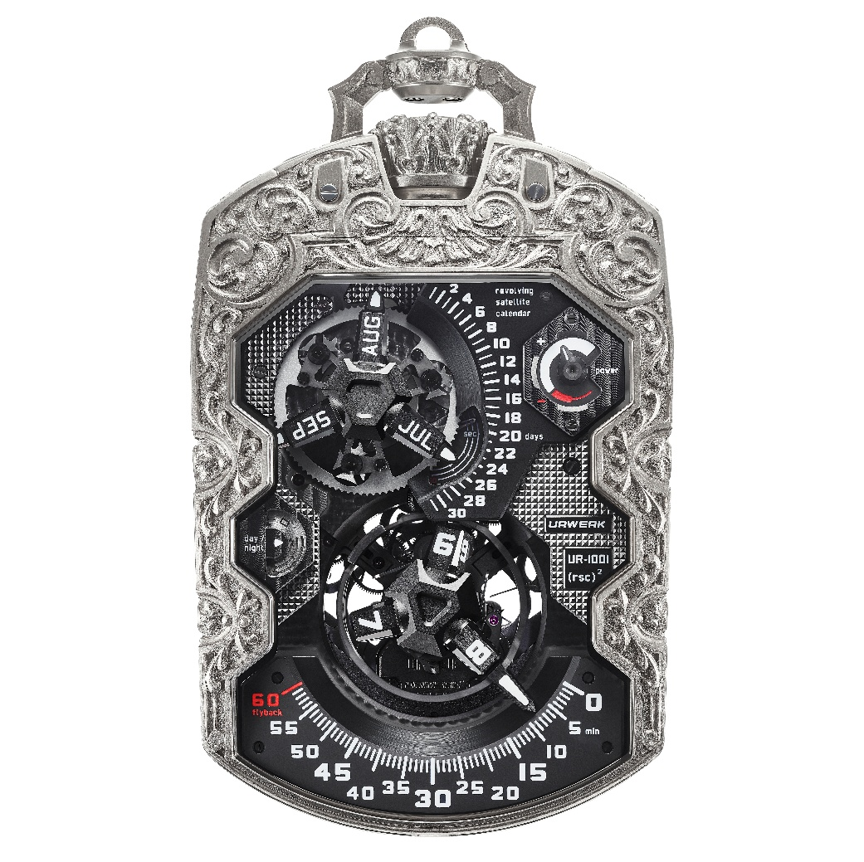

The UR-1001 occupies a place of its own within URWERK’s “Special Projects” collection. It is not only one of the most complex creations ever produced, but also one of the most radical. Conceived as a true Zeit Device, it does not merely measure time but instead maps it. From fleeting seconds to the unattainable millennium, it gives tangible form to that which usually eludes us: Tempus fugit.

Martin Frei tells us the story of this collection's birth: "When we understood that days and months could be displayed using the same satellite concept as our hours and minutes, I immediately dreamed of a wristwatch with this dual indication. But at the design stage, the two carousels were touching. Not enough space. It's out of this dead end that the idea of the UR-1001 was born, an URWERK pocket watch. Beyond this new format, the UR-1001 offers an unprecedented vision of time. Its millennium indicator, for example, is the antithesis of the seconds hand. Its progress is so slow that the eye can barely grasp it. Does it still indicate time? Certainly! It tells us a great deal about how we perceive the passage of time. As an analogy, the UR-1001 is an object of the same standing and almost the same dimensions as a mobile phone. While the cellphone imprisons us in immediacy, our UR-1001 projects you into another temporal dimension, one we might call liberating. “
Few timepieces have thus far spanned such a vast temporal scope. Beneath this spectacular architecture, satellites, carousels, a retrograde mechanism, springs and virtually all the components of its complications have been designed, developed and crafted in URWERK’s workshops. It is nonetheless worth noting that this UR-1001 does not stack complications, instead building a veritable mechanism of time.

Time on the front
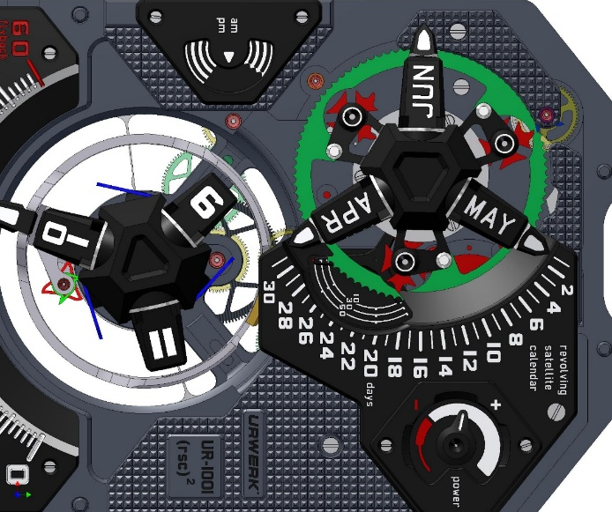
The flying hours satellite at 6 o’clock appears to defy gravity. Devoid of an upper bridge, it rests solely on a moving ring offering an unobstructed view of the spectacular retrograde mechanism.
At 12 o’clock, the satellite annual calendar showcases URWERK’s ingenuity. Three orbital arms cycle through the 12 months of the year, automatically accounting for the specific duration of each: 28, 30 or 31 days.
A hand-painted day/night disc at 9 o’clock makes a striking contrast with a black sky treated with Super-LumiNova® standing out against a finely brushed white ruthenium-plated surface. Between the two, a few dainty lines depict dawn and dusk.
Finally, a dedicated indicator informs the wearer of the 39 remaining hours of power reserve.

Caseback view of time
The reverse side of the UR-1001 tells a story on a completely different scale.
An “Oil Change” indicator records service intervals. During the first three years of operation of this exceptional timepiece, its display remains white. The fourth and fifth years appear in red, signalling that a service is recommended. Once this has been carried out, the counter resets to a new cycle.
Two further indicators extend this long-term perspective on time. The first counter advances in five-year increments and records up to 100 years of operation, much like a mechanical odometer. At the end of each century, it sends a pulse to the 1000-year counter.

Titanium comes to life
A case worthy of such a mechanical masterpiece was required to do it justice. That of the UR-1001 Amadeus becomes a canvas for engraver Florian Güllert to express himself. Under his chisel, titanium loses its apparent rigidity, arabesques appear to emerge from the material itself and the timepiece becomes a sculpture.
The case of the UR-1001 Amadeus is a one-off creation. “We entrusted Florian with an
UR-1001 featuring a raw titanium case, as we wanted the exterior to convey the same sense of extravaganve that embodied in the movement. We wanted the case to be as daring as the mechanics. The nickname ‘Amadeus’ came from the sheer lavishness of the timepiece once it was completed. Mozart was an avant-gardist, a brilliant madman. I hope our creation epitomises that spirit”, explains URWERK co-founder Felix Baumgartner.
Florian Güllert reveals what lies hidden within the block of titanium: “First, I had to rough-cut the material using a laser. This was a new process for me. Titanium is particularly demanding and it was a matter of preparing the raw material for hand-finishing. It was only then that my task really began”, explains Florian Güllert. “The project took nearly three months or around 500 hours of work, including the design phase, yet the most demanding part was undoubtedly engraving the caseback of the UR-1001. I pushed Baroque inspiration to its absolute limit, playing with thick and thin strokes as well as voids. It was a wonderful challenge to tackle”, he concludes.
On this UR-1001 Amadeus, the design gradually sinks into the metal. The reliefs take shape beneath the pneumatic chisel. The backgrounds are textured, dotted, satin-brushed or matt, depending on the desired light effects. Every edge is honed with a file, every detail rebalanced until any boundary between the case and its decoration disappears.
The engraving no longer merely covers the watch, instead becoming its very skin.

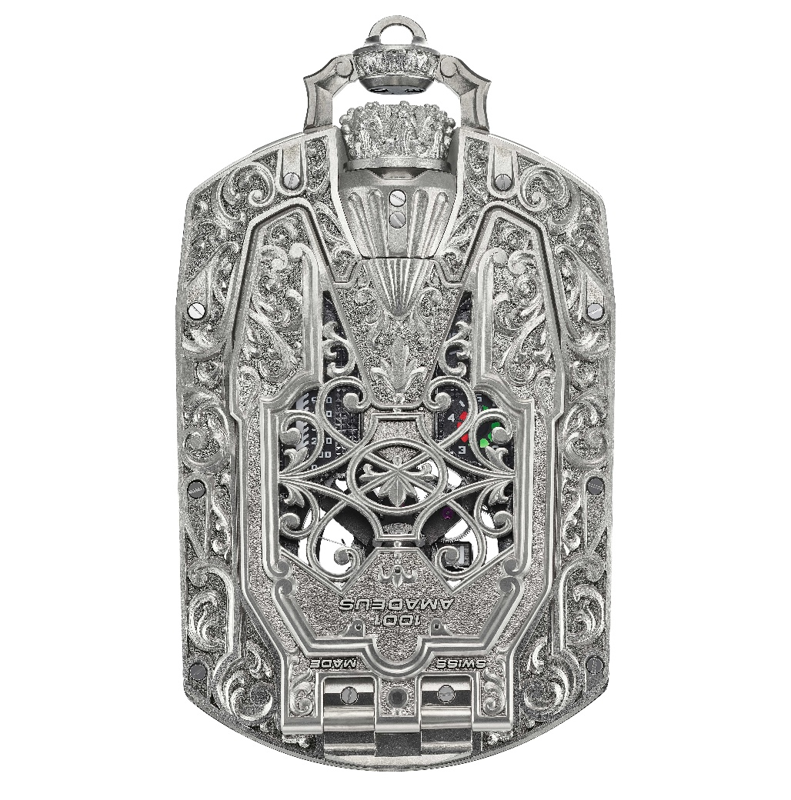

A timeless creation
This UR-1001 Amadeus represents the convergence of two artistic crafts. On the one hand, URWERK’s visionary mechanics, capable of spanning a millennium. On the other, the infinite patience of Florian Güllert, who transforms several hundred hours of work into a design whose complexity nonetheless appears natural.
This UR-1001 is a unique and timeless timepiece: you may never quite be its owner but instead its custodian for a time, before proudly passing it on to the next generation.

UR-1001 – Amadeus
One-of-a-kind creation

Movement
Calibre: | UR-10.01
Jewels | 51
Escapement | Swiss lever escapement
Balance wheel | Monometallic
Frequency | 28,800 vph, 4 Hz
Balance spring | Flat
Power source | Single mainspring barrel
Power reserve | 39 hours
Winding system | Unidirectional rotor
Movement | Co-axial double star with aluminium ring and platinum counterweight. Shock-absorbing safety system
Calendar mechanism | 93-tooth wheel, 3 Maltese crosses
Retrograde minutes spring | 6.5-turn coil (174.4 mm x 0.1 mm x 0.3 mm)  with movable balance-spring stud (adjustable pin). Its great length ensures a very flat torque curve
Main plates and bridges | ARCAP
Screws | Anti-oxidant titanium
Finishes | Frosted plates, adorned with Côtes de Genève motif and DLC-coated; chamfered and polished screw heads

Specifications
Dial side | Rotating satellite hours indicator. Retrograde minutes. Rotating satellite calendar displaying months and dates. Day/Night indicator: black Super-LumiNova for night, brushed white ruthenium for day, mixed stripes for twilight.  39-hour power-reserve indicator with a red zone indicating low reserve.  Seconds: displayed by three hands showing 3 x 20 seconds across a 120° sector.  Côtes de Genève motif on the Day/Night and power-reserve indicators
Caseback side: | “Oil change” indicator (five years)  100-year time indicator  Linear time indicator covering 1,000 years
Finishes: | Sandblasted carousel  Plates, dials and satellites treated with PE-CVD and DLC  Satin-brushed and diamond-polished satellites  Hour-markers treated with Super-LumiNova

Case
Material | Hand-engraved titanium by Florian Güllert
Dimensions: | 106 mm x 62 mm x 23 mm
Crystals: | Glare-proofed sapphire crystals
Water resistance: | Tested to 3ATM
Finishes: | Beadblasted

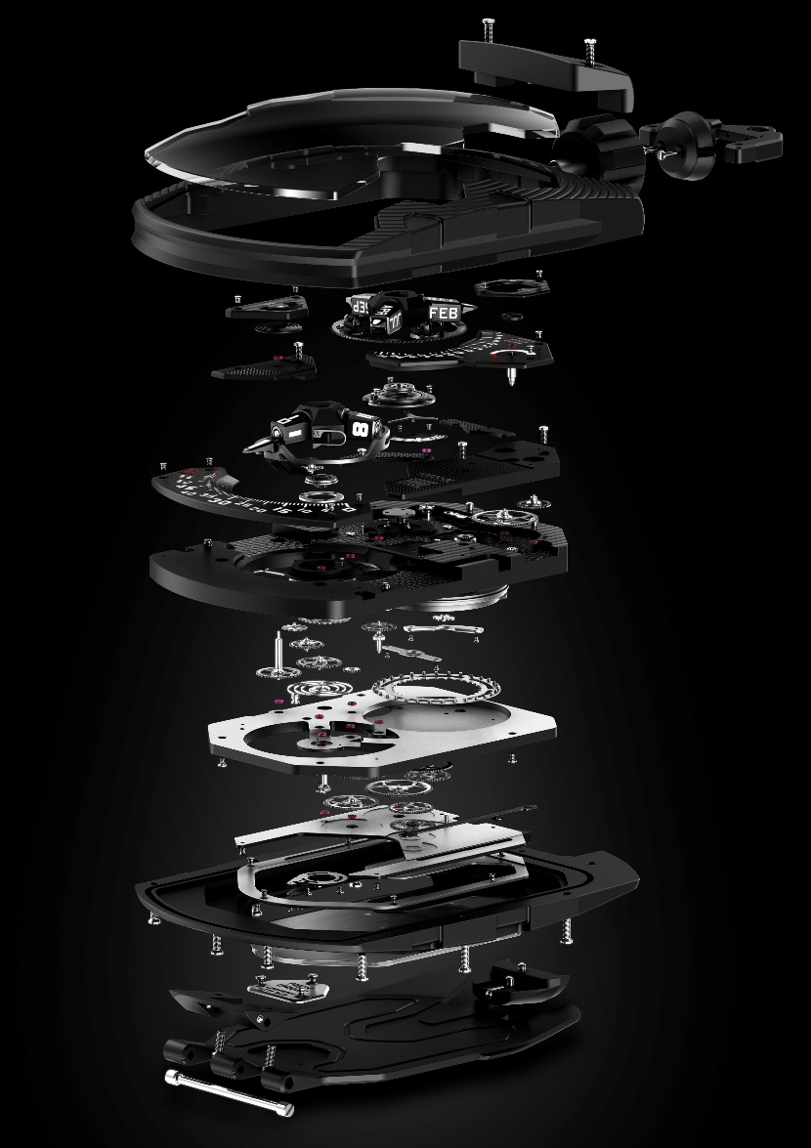

ABOUT URWERK
As URWERK co-founder and master watchmaker Felix Baumgartner explains: “Our aim is not to offer yet another reinterpretation of a familiar mechanical complication. Our watches are unique because each model has required an original design process. Our ambition is to rethink the traditional boundaries of fine watchmaking and push them aside to forge our own path,” he concludes.
This spirit is echoed in the words of Martin Frei, the company’s artistic director and co-founder: “My artistic roots lie in boundless creativity. Freed from the constraints of classical watchmaking, I draw on my cultural heritage to forge a new aesthetic language.”

Although URWERK is a young company founded in 1997, it is regarded as a pioneer in the world of independent watchmaking. With an annual production of around 200 watches, URWERK is an artisan workshop where traditional craftsmanship and avant-garde aesthetics coexist to the full. URWERK designs complex, contemporary watches, unlike any others, which meet the most exacting criteria of Haute Horlogerie: independent research and creation; cutting-edge materials and hand-finishing.

The name URWERK has its roots in 6000 BC in the city of Ur in Mesopotamia. The Sumerians, observing the shadow cast by the sun on their monuments, were responsible for defining the unit of time as we still know it today. Whether by coincidence or as a sign of the times, the word ‘Ur’ also means ‘the beginning’ or ‘origins’ in German. The final syllable of the URWERK signature is also borrowed from the language of Goethe, the verb ‘werk’ meaning to create, to work, to innovate. A tribute to the tireless work of the master watchmakers who have succeeded one another right up to the present day, shaping what we now call Haute Horlogerie.

ABOUT FLORIAN GÜLLERT.
Born in 1972 and raised in Munich, Bavaria, Florian Güllert's path toward mastery began in 1987, when he undertook his training as a gunsmith and stockmaker in Ferlach, Austria - a town whose name has long been synonymous with exacting craftsmanship. Upon completing his apprenticeship, he settled in Münster, Germany, where he launched his professional career as a gunsmith and gun finisher.

It was there that a deeper calling took hold: the art of engraving. In 1995, he returned to Carinthia to study the discipline at the HTL Ferlach, refining and expanding upon the technical foundation he had built as a gunsmith.

Graduating in 1998, he founded Handgraveur Florian Güllert, establishing himself as an independent engraver. From his workshop in Carinthia, he has since lent his hand to a distinguished clientele spanning both national and international horizons.
In 2004, he ventured into the rarefied world of watch engraving - a discipline that has since become the beating heart of his practice, alongside his continued work in jewelry and steel engraving.
In February 2020, he relocated to Hamburg, where he now shares a workshop with his partner, Anja Dammenhayn. Together, they lead Hansegrav, based in Hamburg-Altona.

