**The UR-101 T-Rex,**

**66 million years old and still roaring.**

Geneva – 19 March 2025.

Quake and quiver! The latest addition to the T-Rex lineage is making a big entrance. Bronze carapace, raw presence, primal contact. Not content to be seen, this new arrival demands to be touched.

A specially resurrected UR-101 has undergone the transmutation into a boosted creation covered with textured skin, scaly armor covering its bezel, as well as its sides, as well as its lugs. Usually found on the dial alone – where it is carefully protected under a sapphire crystal the organic *guilloché* pattern – it is exposed here to the touch, filter-free and deliberately inviting contact.

The UR-101 T-Rex wants to face off with the world and here at URWERK we are always ready to rumble.

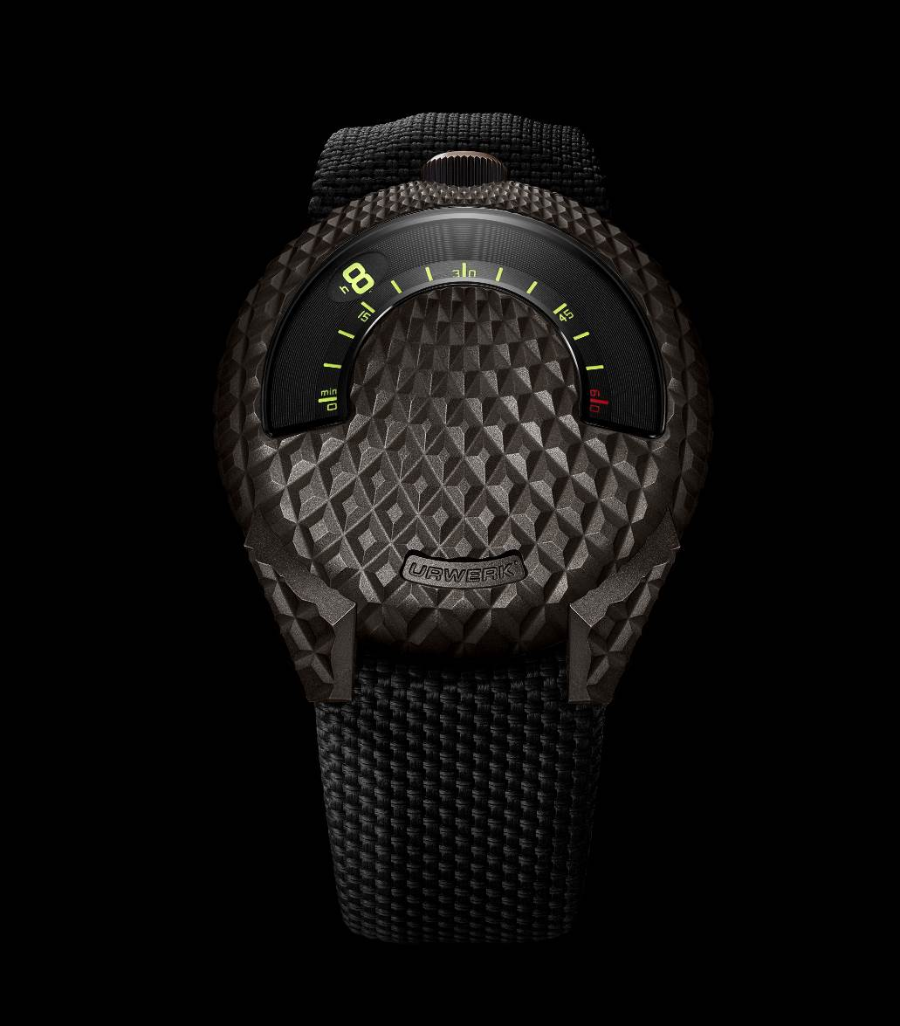

**Living bronze.**

“*Bronze is a fabulous metal”,* explains URWERK’s co-founder and artistic director Martin Frei*. “It reacts to the touch. It is alive. It re-oxidises as soon as it is scratched, and this oxidation protects it and erases the traces of time. It is fascinating, as if reacting like the skin’s natural regenerating process”,* he continues.

The UR-101 is the third URWERK model to be given the T-Rex treatment. Its rounded design triggered the desire for transmutation, providing the perfect base for the characteristic *guilloché* pattern. Take a closer look: the engraved grooves start at the crown, running along the entire case in a low-gradient climb, up to the steep, curved slope leading to the back. One change of pace follows another in a complex, beautiful succession. This 100-piece limited-edition UR-101 T-Rex with its ergonomics inspired by the Millennium Falcon is all about form and substance, surface and depth.

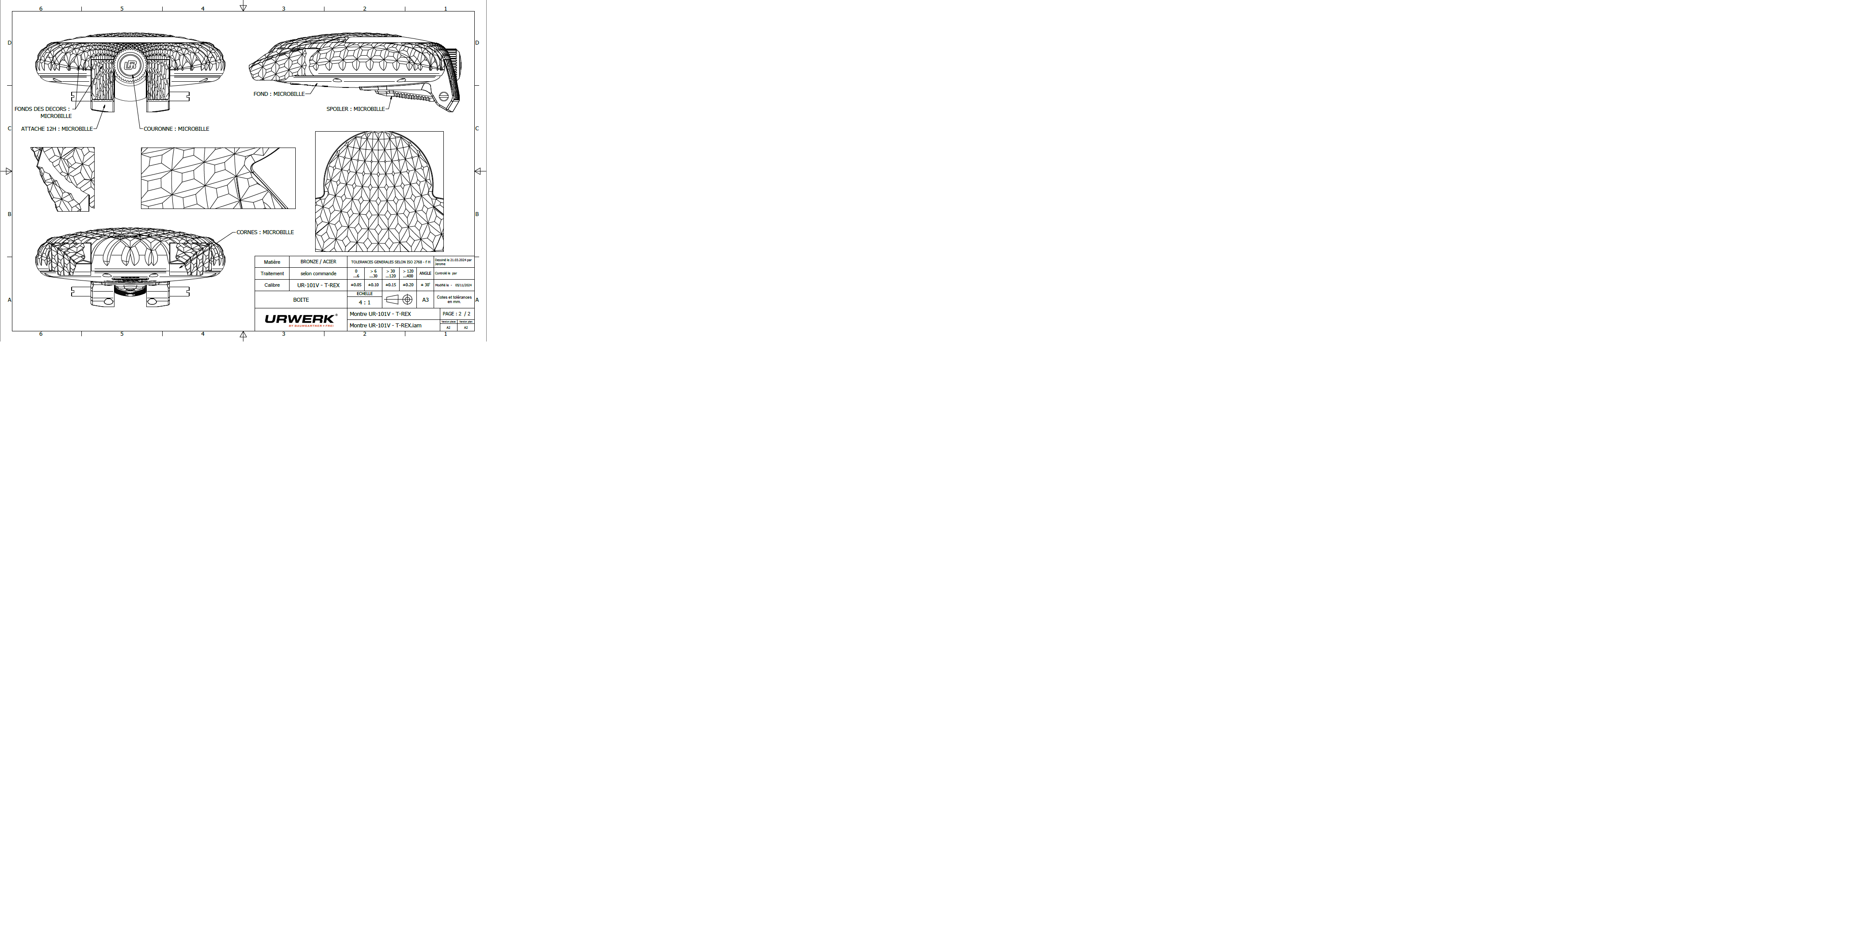

This UR-101 T-Rex measures 41 mm in diameter and 11.86 mm thick at its highest point. Above and beyond the numbers, the way it feels when worn makes all the difference. Its curvature ensures sa natural fit, sitting snugly on the front of the wrist, finding a small niche in which to nestle between two bones. From there on, the asymmetry of the case is revealed, tilting slightly towards the gaze, higher at 12 o'clock than at 7 o'clock thanks to the addition of a ‘spoiler’ with a crown puller that facilitates handling of this creation. Inspired by the very first UR-101, this detail further accentuates its originality.

**Piercing the carapace.**

The bronze from which the majority of the case is made is first guilloched before being oxidized and finally brushed. It will evolve over time, with its brown color becoming even more pronounced, without ever turning green. The same will happen to the inside of the scales, where the graver has been used, as well as for the lugs that are integrated to the back of the UR-101 T-Rex, slightly tilting the case.

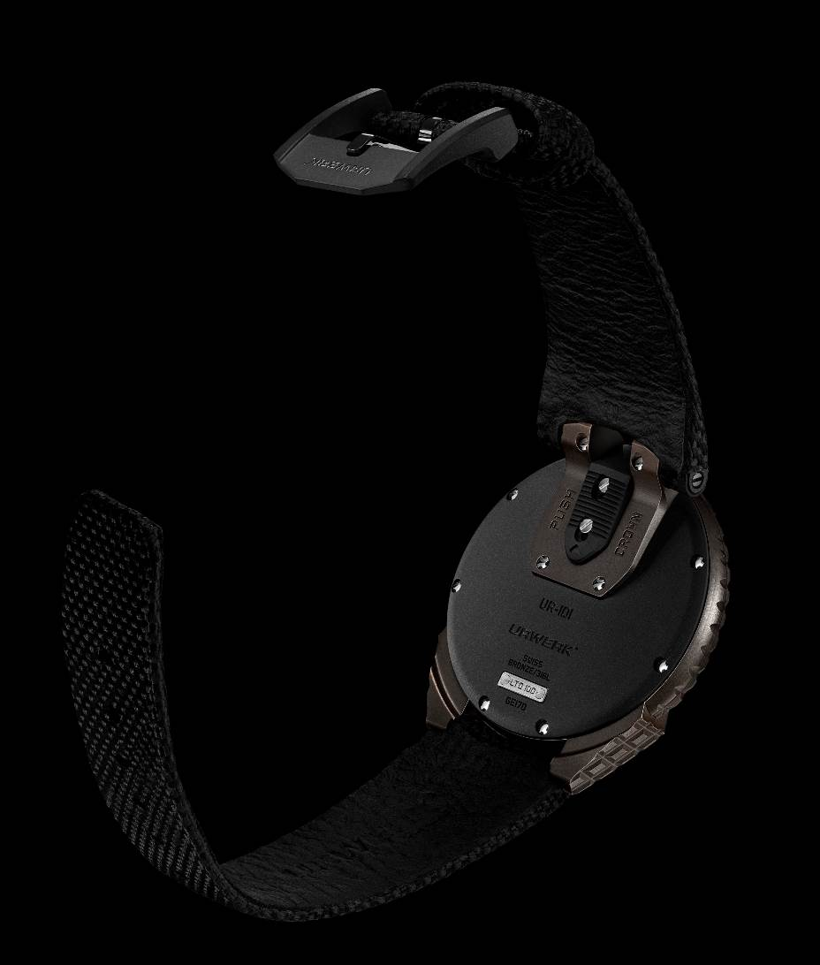

This engraving with a geometric pattern first appeared in 2016 on the UR-105 T-Rex, followed a few years later by the UR-100 T-Rex: “*It's a traditional guilloched dial pattern”,* says Martin Frei*. “We applied it to the entire surface of our case, right up to the edges. You can touch it. It has an animal, physical, almost visceral power.”* The art of finishing – that sometimes overlooked facet of URWERK’s approach – is revealed here on a large scale.

**Delving into the mechanism.**

A reinterpretation of an original URWERK model, the UR-101 T-Rex spells a return to URWERK’s roots. Featuring two satellites, a 180-degree display and a solid, snailed carrousel, this movement is a new expression of brand's technical “wandering hours” signature. The development of the UR-1.01V caliber provides an opportunity for co-founder and master watchmaker Felix Baumgartner to recall the first URWERK movements. “*Our original idea was a satellite time display.* *Making a carousel almost 150 times heavier than two hands move isochronically was our first challenge. It was in conjunction with Svend Andersen, my first watchmaking mentor, that we realized a Maltese cross was required to manage such a mechanism. And that was just the start of the challenges we have set ourselves ever since.*”

The strength of the URWERK universe lies in the collision of imaginations. Between the world of Martin Frei and that of Felix Baumgartner, between the pop culture of their adulthood and the tales of their childhood, between a variety of cinematographic, historical and literary references, the URWERK concepts interpenetrate and coexist in a mash-up where cool meets underground. Alluding to dinosaur scales and the Millennium Falcon, to 18th- and 21st-century watchmaking – all viewed through the prism of the brand's 25-year existence to date – is the essence of URWERK style. A name that evokes Ur the Sumerian city; *Urzeit* as in prehistory; *Uhr* meaning time (and clock); as well as *Werk*, the movement.

With the UR-101 T-Rex, URWERK does not just tell time; it gives it shape and a voice—a roar.

**UR-101 T-Rex – 100-piece limited edition**

|  |  |
| --- | --- |
| **Movement** |  |
| Calibre | UR-1.01V, self-winding |
| Jewels | 28 |
| Frequency | 28,800 v/h – 4 Hz |
| Power reserve | 48 hours |
| Materials | Copper, brass, ARCAP P40 |
| Finishes | Snailing, sandblasting, satin-brushing  Chamfered screw heads |
|  |  |
|  |  |
| **Indications** | Wandering hours on two satellites, minutes  Hours and minutes markers painted with  Super-LumiNova® |
|  |  |
|  |  |
| **Case** |  |
| Materials | Hand-painted *guilloché* bronze case ; black PVD-coated steel caseback ; steel and PEEK crown puller |
| Size | 41 mm in diameter, 9.33 mm thick |
| Glace | Glareproofed, metallised sapphire crystal |
| Water resistance | Pressure-tested at 30m / 3ATM |
|  |  |
|  |  |
| **Strap** |  |
| Material | Black rubber with black calfskin lining |
| Pin buckle | Black DLC-treated steel |
|  |  |
| **Price** | CHF 38,000 (Swiss francs// excl. tax) |

_____________________

Media contact:

Ms Yacine Sar [press@urwerk.com](mailto:press@urwerk.com)

+41 22 9002027

[www.urwerk.com/press](http://www.urwerk.com/press)

ABOUT URWERK

“Bringing out yet another version of an existing mechanical complication was not our aim”, says FelixBaumgartner, master-watchmaker and co-founder of URWERK. “Our watches are unique because each has been conceived as an original work. That is what makes them valuable and rare. Above all, we want to explore beyond the traditional horizons of watchmaking.”

Martin Frei, artistic director and the other co-founder of URWERK who develops the aesthetic signature for each of the models, expresses the same strong convictions. “I come from a world of total creative freedom. I’m not cast in the watchmaking mold, so I can draw my inspiration from my entire cultural heritage.”

While URWERK is a youthful company established in 1997, it is regarded as a pioneer on the independent watchmaking scene. Producing 200 watches per year, URWERK sees itself as an artisans’ workshop where traditional expertise and avant-garde aesthetics coexist in perfect harmony. URWERK develops complex and modern watches unlike any others and meeting the most demanding Haute Horlogerie criteria: independent research and design, cutting-edge materials and hand-crafted finishing.

The roots of the name URWERK date back to 6000 BC and the Mesopotamian city known as Ur of the Chaldees. Observing the shadow cast by the sun on their monuments, the Sumerians first defined the unit of time as we know it today. The word “Ur” also means “beginnings” or “origins” in German and the last syllable of the URWERK signature also comes the same language, since “werk” means creating, working and innovation. A tribute to the constant work of successive master-watchmakers who have forged what we now refer to as Haute Horlogerie.