Fuchsia shock

New York – May 2016.
A pink lotus with a dark side bursts into flower as the latest model in URWERK’s 106 series. Within the UR-106 black pink watch turns a shadowy carousel, encased in gleaming black under an arch of jet-black diamonds. Vivid, shocking pink flares like a firework in the night, focusing the mind on the essential — the hourly milestones of time, as they rotate into position to accomplish their 60-minute patrol.

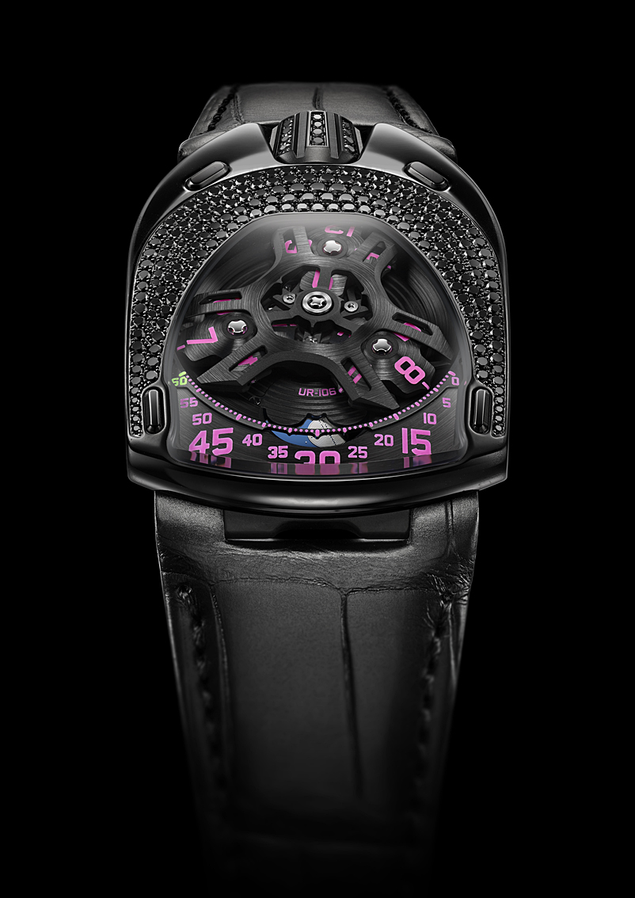

Like virtually all of URWERK’s models, the UR-106 Pink Lotus is based on the wandering hours principle. Three satellite arms, each bearing four numerals, carry successive hours across a scale of minutes in a dynamic display of the inexorable progress of time. A labyrinthine moon sweeps across the night to complete the picture. “We paid particular attention to the details of this UR-106 version,” declare its creators, Felix Baumgartner and Martin Frei. “The carousel and satellites have been worked on by hand to create a special satin finish, while our workshops have carefully painted each hour numeral and cut-out minutes scale. The moon shines in a sky of lapis-lazuli blue selected from hundreds of different shades, while the outline of the lotus on the back is exactly as Martin drew it. We wanted a sleek, handsome watch for our UR-106 series, and for us this is a mission success.”

UR-106 Black Pink Lotus specifications

Movement
Caliber: | Selfwinding cal. UR 6.01 with 48 hours power reserve
Finishes: | Circular graining, sanding, brushing  Chamfered screw heads
Dial | Sanded and brushed baseplate  Carousel and hours satellites sanded and brushed by hand  Openworked minutes track  Labyrinth-style moon in silver on a lapis-lazuli disc  Hand-painted hours and minutes in SuperLuminova
Indications | Wandering hours, minutes and moonphases
Case
Materials: | Steel case and titanium crown, black PVD coated and set with black diamonds, titanium caseback (limited series of 11 watches).
Dimensions: | 35mm wide; 49.4mm long; 14.45mm high
Glasses: | Sapphire crystal
Water resistance: | Pressure tested to 3 ATM (30 meters)

_______________________
Media contact:
Ms Yacine Sar
Tel + 41 22 900 20 27
Mobile: +41 79 834 46 65
press@urwerk.com

www.urwerk.com
www.facebook.com/urwerk
https://twitter.com/URWERK_Geneve

URWERK

“Bringing out yet another version of an existing mechanical complication was not our aim”, says Felix Baumgartner, master-watchmaker and co-founder of URWERK. “Our watches are unique because each has been conceived as an original work. That is what makes them valuable and rare. Above all, we want to explore beyond the traditional horizons of watchmaking.”
Martin Frei, chief designer and the other co-founder of URWERK, develops the aesthetic signature for each of the models. “I come from a world of total creative freedom. I’m not cast in the watchmaking mold, so I can draw my inspiration from my entire cultural heritage.”

While URWERK is a youthful company established in 1997, it is regarded as a pioneer on the independent watchmaking scene. Producing 150 watches per year, URWERK sees itself as a House of artisans where traditional expertise and avant-garde aesthetics coexist in perfect harmony. URWERK develops complex and modern watches unlike any others and meeting the most demanding Haute Horlogerie criteria: independent research and design, cutting-edge materials and hand-crafted finishing.

The roots of the name URWERK date back to 6000 BC and the Mesopotamian city known as Ur of the Chaldees. Observing the shadow cast by the sun on their monuments, the Sumerians first defined the unit of time as we know it today. The word “Ur” also means “beginnings” or “origins” in German and the last syllable of the URWERK signature also comes the same language, since “werk” means creating, working and innovation. A tribute to the constant work of successive master-watchmakers who have forged what we now refer to as Haute Horlogerie.

