URWERK UR-120 BLUE PLANET
The Final Salute from the Cosmos

Geneva – June 11, 2026.
This is the story’s decisive threshold. The mission is accepted, the launch is cleared, and the spacecraft lifts off. Adventure is no longer a promise; it has begun. The hero casts off and plunges into the void… In style!

That hero is the UR-120 Blue Planet.
The third and final iteration of a now legendary model, it claims blue as its signature: deep, almost liquid, suspended somewhere between Earth seen from orbit and the endless azure of infinity. Lifted by touches of gold, this final UR-120 appears to drift between two realities: one governed by the cold precision of mathematical mechanics, the other by tales of exploration, distant galaxies and heroes raising one last farewell before vanishing from sight.
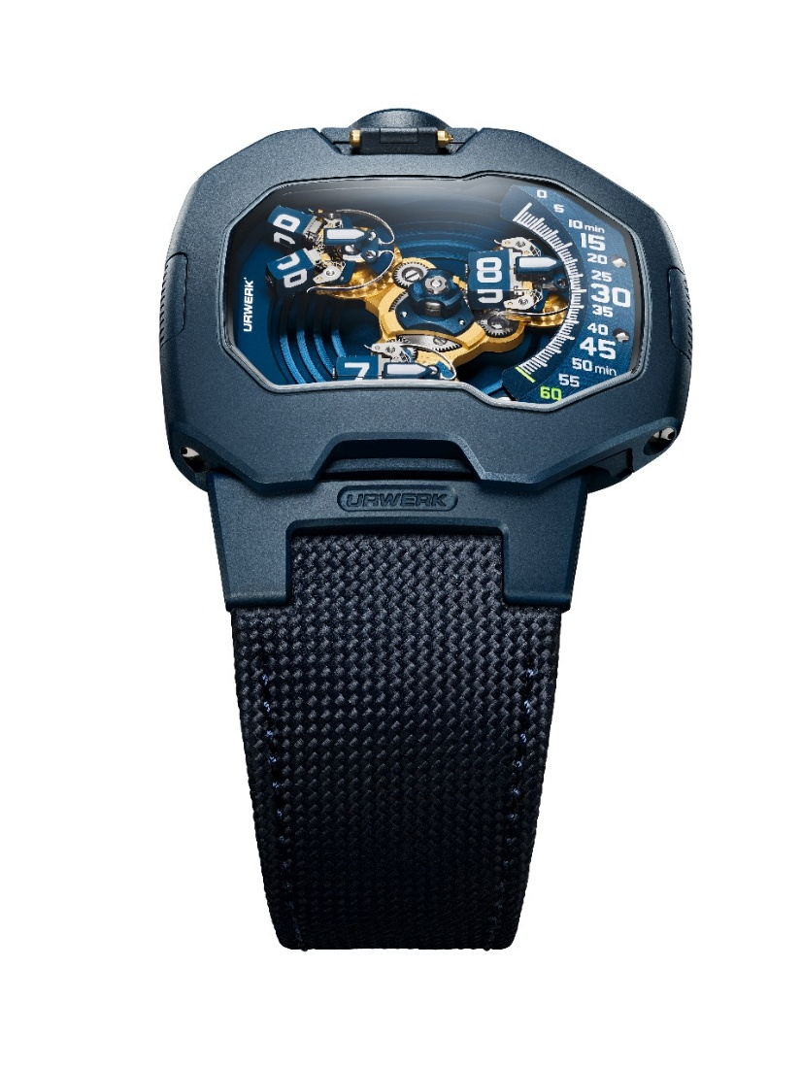

The case: a technical object in the service of style
The UR-120 Blue Planet is built on an interlocking two-part case construction, a structural principle dear to URWERK co-founder and artistic director Martin Frei: " I've always been drawn to this two-part case approach - a base and an upper shell that fit together with precision. A hallmark of Gerald Genta’s work. Technically, it's remarkably clever. You find that idea of a carapace, of built-in protection. The seam vanishes, the assembly becomes invisible. At that point, construction is no longer just a technical constraint, it becomes an act of design."

Here, blue does not soften the UR-120. It sends it elsewhere. The watch becomes the hull of a space module, a fragment of interstellar architecture, an object designed for another atmosphere. Its smooth upper surface, free of visible screws, seems to stretch forward. The domed sapphire crystal draws the eye into the display. The articulated lugs - a rare feature in URWERK design - extend the case with seamless continuity, while a spring concealed within the 6 o’clock lug fine-tunes the fit on the wrist.
Nothing is accidental. Nothing is just cosmetic. Every detail serves the structure, the ergonomics and the visual trajectory of the watch.

The calibre: kinetics of a salute
At the heart of the UR-120 Blue Planet beats Calibre UR-20.01, a mechanism designed not only to indicate time, but to stage it. Three hour satellites orbit a central carousel. Each advances in turn along the minute track before leaving the stage to prepare for the next hour. Then comes the gesture. As a satellite reaches the left-hand side of the case, it opens. Its two rectangular arms split apart to form a V. The Vulcan salute comes to life.
Familiar to generations of science-fiction devotees, this gesture is transformed here into a genuine horological complication. The carousel rotates. The satellites counter-rotate to remain legible. The arms pivot independently on their own axis. Their opening and closing are controlled by a lyre-shaped spring, while Maltese crosses choreograph each sequence with absolute precision.

Felix Baumgartner, URWERK co-founder and master watchmaker, explains: “In actual fact, once we realised we had to open these satellites, it became a cause for personal celebration. A new horological conundrum to solve. The UR-120’s carousel alone comprises 175 components, while the complexity of the satellites requires us to control their interactions to the nearest micron. Our challenge has always been to optimise the forces in play. Energy management is delicate and intricate. Among other things, we used our signature Maltese cross element and produced the lyre-shaped spring at the heart of this complication in our own workshops.”

Gold: when function becomes light
Against the deep blue architecture of the UR-120 Blue Planet, the lyre springs and Maltese crosses are finished with a 24K yellow-gilt PVD coating. Here, gold is not an ornament. It reveals the function. It draws the eye to the active components, the points of tension, the parts where energy is stored, released and transformed into motion.
Like the Bussard collectors glowing at the front of the USS Enterprise’s warp engines, these gilded elements seem to capture and channel power. Every passing second becomes energy made visible. Every mechanical impulse becomes light.
Soaring towards the stars
The UR-120 Blue Planet does not announce a sequel. It is a final transmission.
For one last time, its satellites open. For one last time, that fleeting V-shape appears beneath the sapphire crystal. A Vulcan salute. A signal from the bridge. A nod to those who grew up with distant galaxies, impossible spacecraft and the belief that adventure might begin at any second.
The final UR-120 does not take a bow.
It soars away in a blaze of golden fireworks, then vanishes into the blue !


Technical specifications
UR-120 Blue Planet
Limited edition of 20 pieces
Movement
Calibre | UR-20.01, self-winding
Jewels | 32
Escapement | Swiss lever
Frequency | 4 Hz / 28,800 vph
Power reserve | 48 hours
Materials | beryllium copper, anodised aluminium, ARCAP, titanium, brass, LIGA-processed blue ALD (atomic layer deposition)-treated, 24K yellow-gold PVD-treated.
Finishing | circular graining, straight graining, sandblasting, Côtes de Genève motif, polished screw heads
Indications
 | Analog minutes and dragging satellite hours displayed on triple planetary gears
Case
Dimensions | 47 mm wide, 44 mm long, 15.8 mm thick
Materials | sandblasted steel
Crystal | anti-reflective sapphire crystal
Water resistance | pressure-tested to 3 ATM / 100 ft / 30 m
Strap
 | Blue Cordura-textured calfskin strap with satin-brushed steel pin buckle with blue PVD
Price
 | CHF 115’000.00 (Swiss francs /tax not included)
_____________________
Media contact
Ms Yacine Sar +41 22 900 2027
yacine@urwerk.comn www.urwerk.com/press

About URWERK
As URWERK co-founder and master watchmaker Felix Baumgartner explains: “From the very beginning, we refused to confine ourselves to the well-trodden paths of traditional Grand Complications. Our ambition has always been to push the boundaries of watchmaking and create timepieces that stand as works of original and unique craftsmanship.”
This spirit is echoed by Martin Frei, URWERK’s artistic director and co-founder: “My artistic roots lie in boundless creativity. Freed from the constraints of classical watchmaking, I draw on my cultural heritage to forge a new aesthetic language.”

Founded in 1997, URWERK is recognised as one of the pioneers of independent watchmaking. With annual production limited to around 200 watches, the Swiss Maison operates as a horological laboratory where cutting-edge technology and radical design converge into a single vision.
Its creations are organised into three distinct lines: the Satellite collection, the brand’s icon, where wandering hours redefine the perception of time; the Chronometry collection, a field of experimentation dedicated to precision and avant-garde mechanics; and Special Projects, a realm of boldness and innovation.

URWERK timepieces are modern, complex and resolutely unique, while remaining loyal to the highest standards of fine watchmaking: independent research, advanced materials and meticulously hand-finished details.
The name URWERK pays tribute to both antiquity and the avant-garde. It evokes the Mesopotamian city of Ur, where the Sumerians first measured time using the shadows cast by their monuments, and is rooted in the German words Ur - original or primeval - and Werk - work or mechanism. Together, they express the idea of an “original mechanism”: the perfect symbol of a Maison dedicated to reinventing the very concept of time.

