**The UR-150 Scorpion**

**URWERK’s new lethal masterpiece.**

**Geneva – October 2024.**

**URWERK reinvents its iconic satellite hours complication. A new mechanism for a new scenography. The UR-150 Scorpion appears in a rounded shell. But don't be fooled by its calm, relaxed facade: the UR-150 hides a fearsome device, a lightning sting whose lethal function is triggered in a hundredth of a second.**

**Beware the fierce mechanism!**

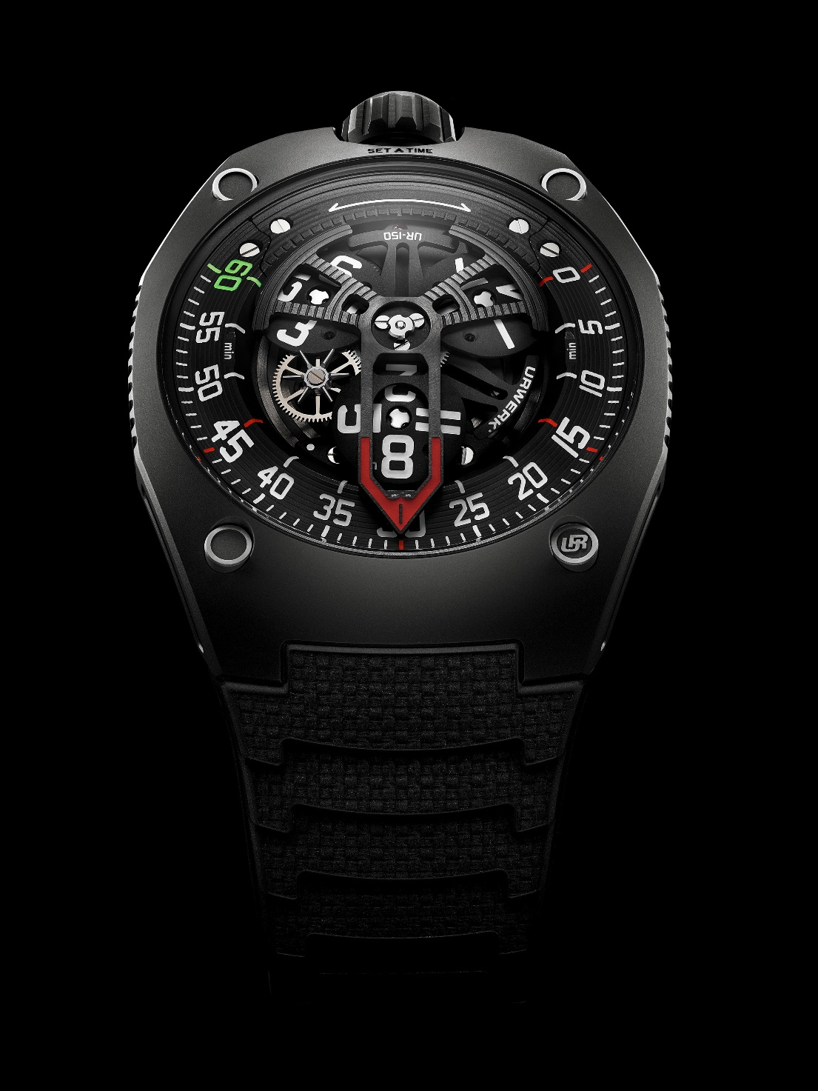

It's one of Muhammad Ali’s most famous mottos and the secret of his success: ‘Float like a butterfly, sting like a bee’. It’s a statement that could easily be applied to the latest creation from URWERK, the UR-150, a watch that also flies and stings… but like a scorpion. Inspired by the arachnid’s stinger, the nickname of this creation references the trajectory of the 240-degree minutes sector, resembling a scorpion’s tail poised to attack. This symbolism also extends to the retrograde minutes hand, ready to unleash its blistering power as it strikes each passing hour… fast and fearsome.

Hammerhead, Tarantula, Cobra, Scorpion: URWERK has repeatedly been inspired by menacing creatures. “*We've once again chosen an evocative nickname for our creation and the scorpion is indeed a nasty beast – yet the design of the UR-150 is gentle.* *It’s very URWERK … the aggressive symbolism belies the reality of the watch’s cool, calm personality”,* says Felix Baumgartner, master watchmaker and URWERK co-founder, with a laugh*.* *“We choose to inhabit an extreme world, because we are anything but ordinary and reasonable*”, he continues.

This UR-150 features a large openworked hand framing the prevailing hour. The tip of this hand arcs over the minutes track. Once the 60th minute has elapsed, the hours hand jumps to zero and the journey begins anew. At the same time, all the satellite hours spin on their axes and the retrograde hand frames a new hour – all in just 1/100th of a second.

The model’s retrograde mechanism present here is reminiscent of the one seen on mechanical automaton: a flying carousel bearing the three hour satellites follows a route determined by a cam. The latter orchestrates the motion of the carousel, a performance that lasts precisely 60 minutes. As the hour hand reaches ’60’, depicted in green numerals, an URWERK spring triggers the UR-150's lightning-fast attack: the retrograde hand makes a 240° jump and the hour satellites simultaneously rotates 270°. “*It's like a perfect alignment of the stars, a perfect storm”,* says Felix Baumgartner. *“In order to drive all the satellites, guide the hour hand and ensure that each element jumps at just the right time, we have designed a new satellite complication system.* *It is based around a flying wheel and pinion positioned between the satellites and the base movement.* *It deciphers and follows the ‘guiding thread’ of a cam.* *We have therefore replaced our ‘classic’ device based on Maltese crosses with this cam and a rack system. This necessitated developing a spring so special that we needed to machine it in our own workshop.* *To make this burst of movement more visible, we have doubled the usual distance between the 60 and 0 markers”,* he concludes.

The minutes display on the UR-150 is more expansive and more ambitious, moving from the usual 120 degrees to a 240° arc. Optimising available energy is essential to maintaining perfect isochronism and achieving the ‘Perfect Storm’. The retrograde system is the most ambitious ever undertaken by URWERK. The weights employed are the greatest ever used and the speed and inertia the most intense, necessitating the creation of an unprecedented means of controlling the various dynamic forces at play. This technical feat is achieved using a speed regulator fitted to the UR-150’s flywheel, a mechanism usually employed to regulate the chiming sequence on a minute repeater. In this it smooths the return of the retrograde hand.

The automatic winding system is among several innovative features found on the UR-150. Equipped with a double set of turbines, the ingenious system regulates the solid rotor’s speed. It delivers unprecedented energy and shock-resistance. As Felix Baumgartner explains, “*The aim of the turbines is to absorb shocks to the rotor and avoid them affecting the arbor.”*

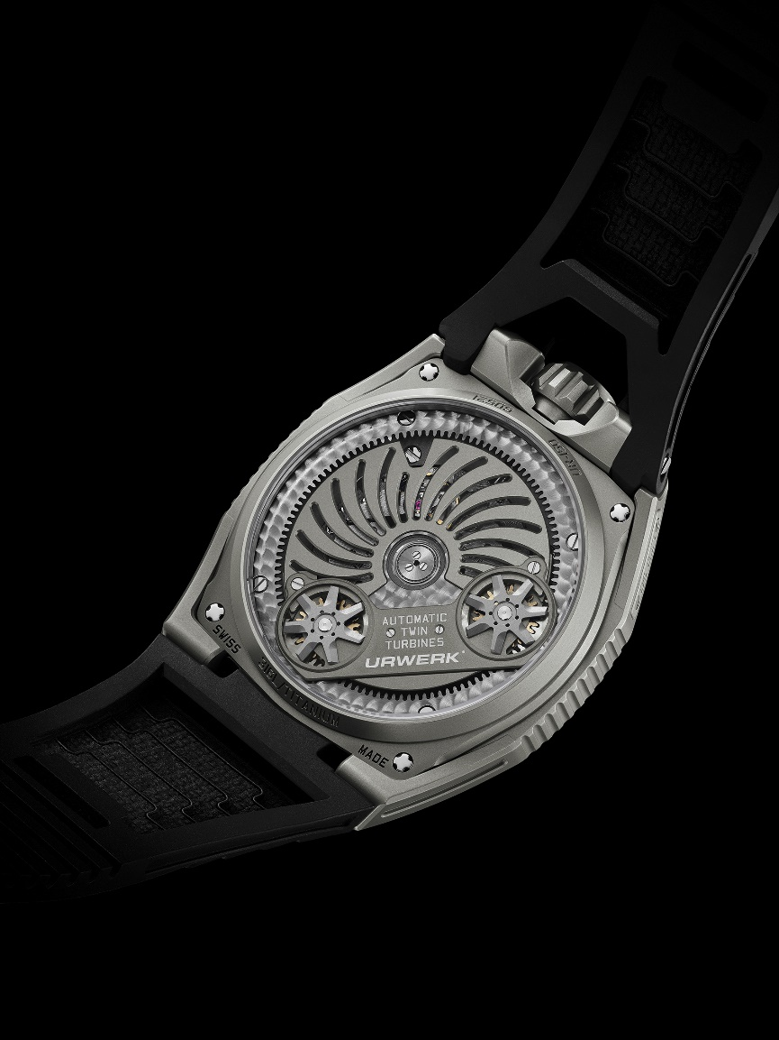

The UR-150 also showcases a new artistic direction. The hard sting of the ‘Scorpion’ nickname contrasts with the organic shape of this new model. When designing the inaugural UR-100 collection, the Maison adopted an alternative approach to design: “*It's an evolutionary process”*, explains URWERK’s Creative Director and Co-Founder Martin Frei. “*We like to play with lines and enjoy juxtaposing gentle curves with acute angles.* *Here, the profile of the case and sapphire crystal is a section of the same shape – meaning perfectly spherical – while the minutes hand shares exactly the same curve.”*

Viewed from the side, the UR-150 features an arched profile, with the case and sapphire crystal extending from the curve of the bracelet along the same curved line, ergonomically hugging the curves of the wrist. The curvature extends beyond the case and into the movement itself, since the satellites and hours hand share the same sloping profile. “On this *UR-150 you can read the time without twisting your wrist.* *The present faces us, confronts us.* *Everything is a matter of detail, a game of positioning.* *The tension between the gentle contours of the case and the forceful motion of the mechanism imbues the UR-150 with vitality … with energy”,* says Martin Frei*.* “*I'm not interested in harmony”,* he points out, convinced that *“Beauty appears through a field of tensions.”*

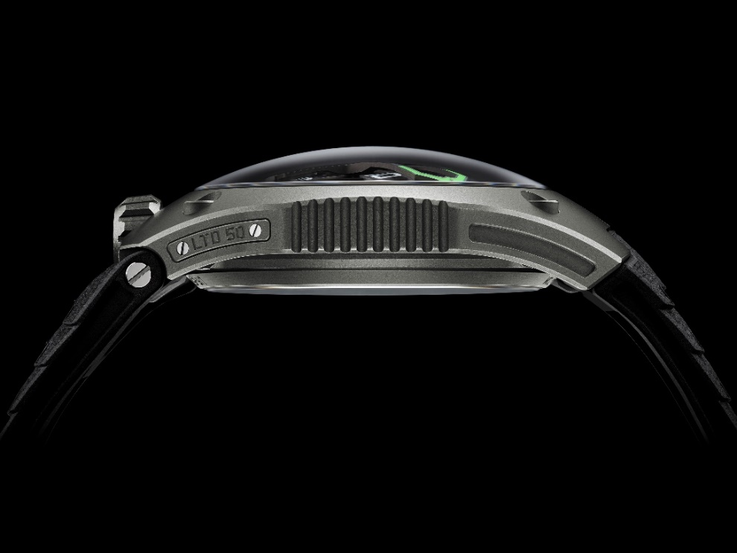

Inside this new body, URWERK has installed the latest evolution of its wandering satellite-hour movement. The UR-150 delivers a sense of theatre when one hour dramatically transitions to the next. *“It's a vibration in the spacetime continuum”,* Martin Frei continues*.* “*This moment of turning back time is very special.* *Can one lose or gain time?* *At URWERK, we love this moment, we wait for it and we observe it* *– and all the more so because it has a dual nature.* *While the minutes tick by slowly, in the absence of a seconds indicator, the minutes hand returns to its point of origin instantaneously.”*  
  
The UR-150 will be available in two variations - Titan and Dark - of 50 pieces each.

**Technical specifications**

|  |  |
| --- | --- |
| **Movement** |  |
| Calibre | UR-50.01 with automatic winding system governed by a double turbine |
| Jewels | 38 |
| Frequency | 28,800 vph - 4Hz |
| Power reserve | 43 hours |
| Materials | Aluminium satellite hours on a brass carousel; aluminium retrograde hand |
|  | Circular graining, sandblasted, shot-blasting, circular satin finishing  Chamfered screw hands  Hours and minutes index incorporating Super-LumiNova® treatment |
| Indications | Satellite hours; minutes |
|  |  |
| **Case** |  |
| Material | Sandblasted and shot-blasted titanium and steel for the Titan version  Sandblasted and shot-blasted titanium  Anthracite PVD -treated steel for the Dark version |
| Dimensions | Width: 42.49mm x length: 52.31mm x  thickness: 14.79mm |
| Glass | Sapphire crystal |
| Water resistance | Screw-lock crown. Pressure tested at 5ATM (50m) |
| Strap | KISKA rubber strap |
| **Price** | *Titan version* CHF 88,000 (Swiss francs / excl. tax)  *Dark* *version* CHF 89,000 (Swiss francs / excl. Tax) |

Press contact:

Mme Yacine Sar +41 22 900 2027

[press@urwerk.com](mailto:press@urwerk.com) [www.urwerk.com/press](http://www.urwerk.com/press)

URWERK

*“We don’t try to bring out new versions of existing complicated mechanisms”,* explains watchmaker Felix Baumgartner, master-watchmaker and co-founder of URWERK. *“Our watches are unique because they are all designed as original works, which makes them rare and priceless. Our main aim is to go beyond the traditional horizons of watchmaking and to overturn them so as to blaze our own trail”,* he concludes.

The original styling of each URWERK model is masterminded by chief designer Martin Frei, the company’s other co-founder, who states: *“I come from a background where creativeness has no limits. I am in no way prisoner of the traditional constraints of watchmaking, hence I am free to celebrate my cultural heritage.. a source of much inspiration.”*

Although URWERK is a young company established in 1997, it is recognised as a pioneer among independent watchmakers. Producing just 150 watches a year, the company sees itself as a craftsman’s studio where traditional expertise coexists with avantgarde styling. The company manufactures modern and complex watches that are unprecedented and in keeping with the most demanding criteria of fine watchmaking: independent design and research, advanced materials and handcrafted finishes.

The name URWERK comes from the ancient city of Ur of the Chaldees in Mesopotamia, founded nearly 6,000 years ago where the Sumerian inhabitants first established units of time based on the shadows cast by its monuments. Ur in the German language also means primeval or original and Werk means an achievement or a mechanism. Thus, URWERK can be translated as an original movement – a tribute to generations of watchmakers whose work has resulted in what we know today as *Haute Horlogerie*, or superlative watchmaking.