UR-210 Black Platinum

Geneva – January 2018
Once they’ve seen it in action, nobody can deny the appeal of the UR-210. To appreciate it fully you have to keep your eyes glued to the dial as the minutes hand approaches the end of its hour. Don’t blink, because if you do, you’ll miss a display of controlled energy in the lighting return of the retrograde hand as it snaps back to the start of the next hour.
Today URWERK presents the extraordinary UR-210 in a black platinum version, in keeping with a tradition held since its foundation. The Black Platinum model is the most select and exclusive of the UR210s, and as such, irresistible.

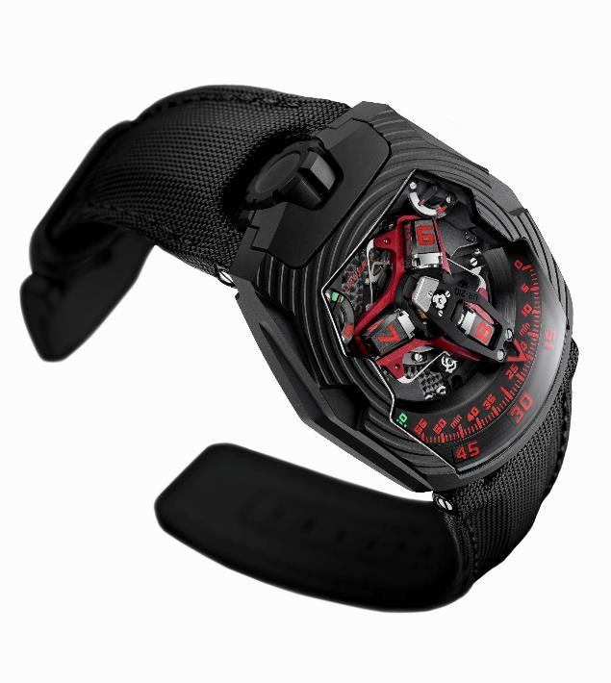

It’s a few seconds to the hour and time holds its breath as it prepares to return the minutes to their starting point. The action is too swift for the eye but you hear the sharp click that announces the arrival of the hand exactly on zero.
The spectacular combination of the revolving satellite complication and retrograde minutes is seen nowhere as in the UR-210. The prominent three-dimensional minutes hand acts as a high-tech cowling that encloses the hours and carries them in turn smoothly across the scale of minutes. The lightning speed of the flyback— less than a tenth of a second — depends on three key factors:

- The central hub ensures that the mechanism remains stable. Turning on ruby bearings, it constitutes the rock on which the entire complication rests. A cylindrical spring of the type used in marine chronometers along the shaft accumulates the power for the retrograde action.

- The unusual minutes hand that acts as a cowling to transport the hours has equally uncommon dimensions, machined to the hundredth of a millimetre. The 22.29mm long metal structure, with a width of 8.03mm and a height of 7.3mm, weighs only 0.302 grams. Machined in aluminium, it is perfectly balanced by a brass counterweight.

- A double coaxial cam in the shape of a star governs the retrograde action. Its gearing and then its rotation determine the trajectory of the minutes hand.

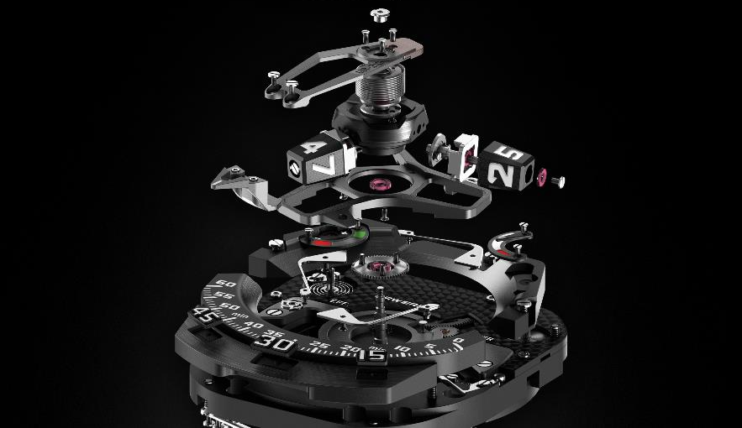

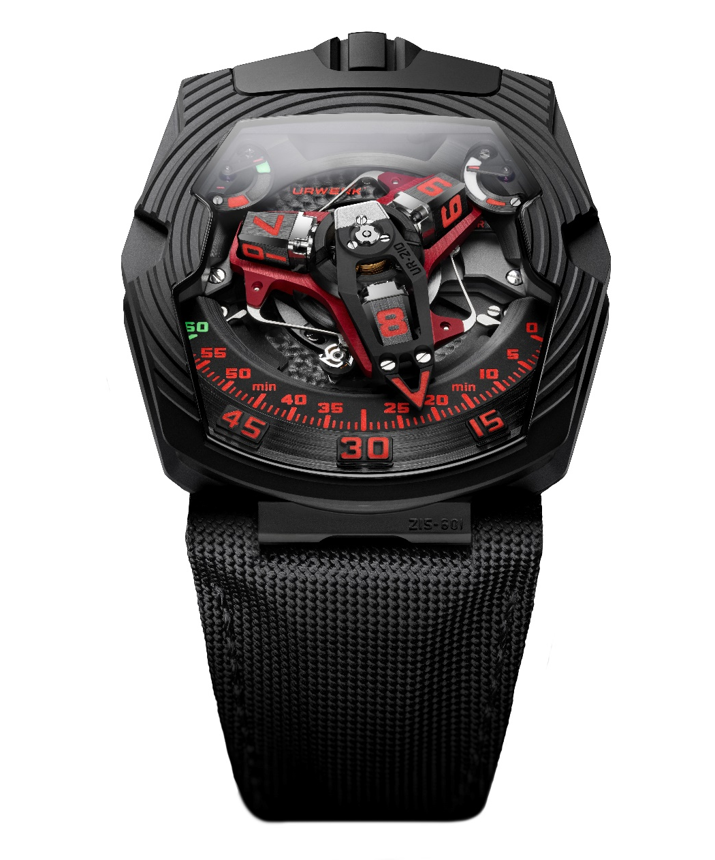

The case of the UR-210 black Platinum appears to have reacted to the force of the fly-back minutes, developing a series of regular shock waves radiating from the dial. An allegory has become reality. “We’ve added an extra tactile dimension to a 3D watch,” explains Martin Frei, URWERK’s co-founder and designer “The rotations of the hours satellites are replicated in the metal of the case. As if we had created a shockwave powerful enough to displace matter and bend platinum. The deep furrowed arcs also accentuate the smart hexagonal design of the case.”

The dial of the UR-210 also features a conventional power-reserve indicator at 1 o'clock. Opposite, at 11 o'clock, what appears to be a similar indication is in fact very different because it shows the winding efficiency during the last two hours.
This device — a world first — calculates the energy flow, or the ratio between the energy generated and the energy consumed. Contrary to a torque indicator, it doesn’t depend on the tension of the barrel spring.
Are you sitting comfortably, not moving much? Then the hand of the winding efficiency indicator will move inexorably towards the red sector. When it’s workout time, it will move towards the green, showing more energy is being created than consumed.
Knowing the winding efficiency of your watch enables you to adjust the winding rate. If your UR-210 shows that not enough energy is being generated, you can turn the winding rate adjuster on the back of the watch to FULL. The winding rotor then becomes sensitive to the slightest motion, converting it into pure energy. The rotor is connected to a turbine that ensures an optimum winding rate while dampening shocks. If your activity creates too much energy, turning the adjusting wheel to REDUCED absorbs some of that energy to prevent unnecessary stress on the mechanism. A turbine mounted on ruby bearings starts to spin, acting as an air compressor and creating a resistance that slows down the winding rotor. In the STOP position, the self-winding system is disengaged and the UR-210 becomes a manually wound watch.

“With this model, URWERK reaches a new goal,” concludes Felix Baumgartner, master watchmaker and co-founder of the brand. “At the same time it opens a new chapter in the evolution of our complicated mechanisms. They now go beyond an original way of measuring a universal phenomenon to initiating a dialogue between the watch and its owner. The UR-210 indicates personal measurements, derived from you and no-one else.”

UR-210 Black Platinum limited edition of 25 watches

Technical specifications
Case
Material | Platinum and titanium with black DLC coating.
Dimensions | Length 53.6mm; width 43.8mm; height 17.8mm
Glass | Sapphire crystal
Water resistance | Pressure tested to 3ATM/30m
Movement
Calibre | UR-7.10
Jewels | 51
Escapement | Swiss lever
Balance wheel | Monometallic
Frequency | 28,800v/h, 4Hz
Balance spring | Flat
Power source | Single barrel
Power reserve | 39 hours
Winding | Automatic winding dampened by turbines
Materials | Baseplate in ARCAP P40; three-dimensional minutes hand in aluminium with brass counterweight; central cylindrical spring in steel; hours satellites in aluminium; central carrousel and screws in grade 5 titanium.
Finishes | Sanded and circular-grained baseplate; satin finished and diamond-polished satellites; chamfered and polished screw heads.
Indications
Patented satellite complication showing wandering hours; three-dimensional minutes hand; power-reserve indicator; patented winding efficiency indicator.
Hours, minutes and markers painted in Super-LumiNova®

Controls | Two-position winding and setting crown  Winding regulator on the back
Price | CHF 155’00.00 (Swiss francs / no tax added)
____________________________________
Media contact:
Ms Yacine Sar press@urwerk.com
+41 79 834 4665 +41 22 900 2027
www.urwerk.com

