**The UR-230 Polaris**

**A tougher shade of white**

**Geneva – December 11th, 2024**

**Radiant and iridescent, the second installment in the 230 series inaugurates a color and a material that both depart from URWERK's historical language. With its white case, carved from a block of proprietary fiberglass-enhanced ceramic, the UR-230 Polaris opens a new color horizon, a polar perspective. So far devoted to using black, gray, and muted textures, URWERK dramatically pivots towards natural brilliance and a new energy that glimmers white.**

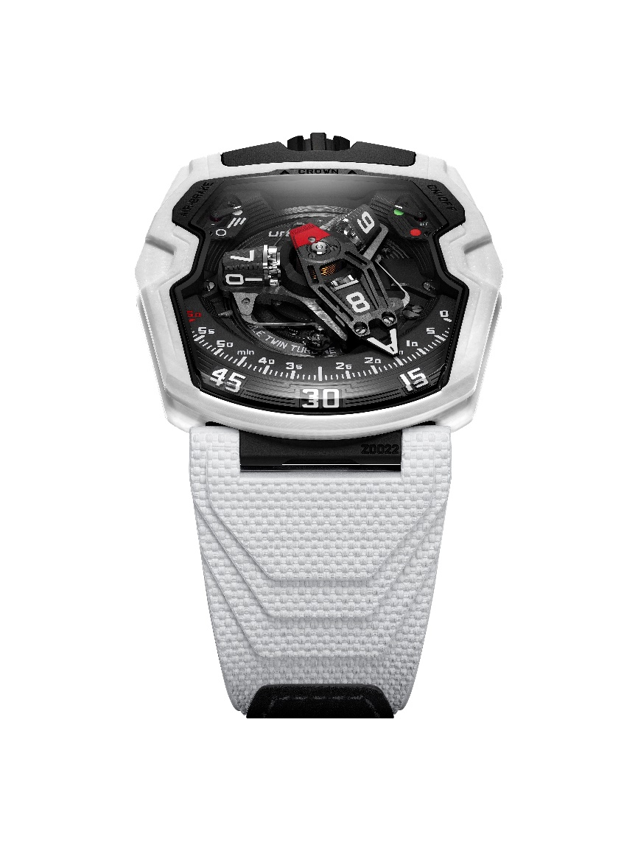

Just a year after the release of the UR-230 Eagle - the first opus in the 230 series and entirely crafted out of TPT carbon - URWERK is already shifting this new collection towards a wholly new and immaculate intent. With its technical base unchanged, the UR-230 dons a pure white, highly technical material, stemming from an exclusive and proprietary development.

**Hard and tough**

The UR-230 Polaris is made of a layered, ceramic-based composite. Its polymer base houses sheets of woven ceramic, intertwined with fiberglass plies. Used in the airspace, medical and henceforth, watchmaking industries, this new and high-performance material combines the advantages of each of its constituents.

« The usual ceramics are hard, but it's also what makes them a liability, says Felix Baumgartner, master watchmaker and co-founder of URWERK. These materials are heat-sintered, which makes them prone to shattering in case of a strong impact. We had to go past that limitation. So we decided to develop a ceramic, by and for ourselves. Thanks to the glass fibers it contains, it doesn't break."

**White and silver**

Not content with overcoming the main weakness of watch-specific ceramics, the UR-230 Polaris has another ace up its sleeve. The resin that encapsulates the fiber-based sheets is colored white, while the fiberglass is a very light silver. Machining the case into its complex shape reveals the finely stacked layers, with a varying effect depending on the curve and angle. They share a graphic component with carbon fiber: uneven and shimmering. Shifting from full matte to slightly glowing, they offer random plays with light. That specific white is alive, constantly changing, and subtly so. It entirely contains the almost all-black URWERK caliber UR-7.30.

This unique take on white came after thoughtful consideration, as explains Martin Frei, art director and co-founder of URWERK: « The white case outside and the black movement of the UR-230 Polaris, especially with a white strap on, are strongly reminiscent of the aesthetics of 2001: A Space Odyssey. They're a throwback to Kubrick's breathtaking set designs and the iconic Discovery 1 spaceship. This design also hints at the entire Apollo 11 aesthetics as created by NASA, where white was used as a heat shield, an absolute requirement of space dwelling. This watch is not only elegant, it's also got NASA cool written all over it. »

**Jump and switch**

The new UR-230 Polaris is a sophisticated version of the revolving satellite complication that is URWERK's essential signature. On a three-armed carousel, rotating blocks each carry four hours’ numerals. They scroll along a 120-degree section, with the face of the current hour pointing towards the observer.

These display cubes are embedded in an aluminum 3D retrograde hand to display the minutes. Echoing the case and strap color, this skeletonized hand is also white. At the end of its 60-minute journey, it returns to index 0, where it takes charge of the cube displaying the next hour.

**Air and flow**

In addition to this time display, this ceramic iteration showcases the UR-230's new functions. URWERK has developed a world-first set of shock absorbers designed to protect the new UR-7.30 caliber via turbines. The first set of turbines is dedicated to attenuating the impact of any external shock, thereby guaranteeing the robustness and durability of the watch.

A second set controls the flow of air that feeds the winding system. The strength of this "air brake", designed to modulate the winding power according to the wearer's level of activity, is set by a rotating knob on the back of the watch. A second switch opposite the first serves to disengage the rotor entirely. The UR-230 Polaris then switches to manual winding mode. Two symmetrical indicators indicate the level of adjustment of these two functions at 11 and 1 o'clock.

**Heart and body**

From the 200 collection, which it derives from, the UR-230 Polaris retains the case design. A trapeze shape with a pronounced elongation towards the 6 o'clock position, a staggered layout around the sapphire apertures, a crown at 12 o'clock and clever management of acute and softened angles: the UR-230 Polaris asserts its fundamentally URWERK nature.

Inside the case, the UR-7.30 caliber is encased in a hermetically sealed container resembling a strongbox. The white ceramic case and black DLC titanium caseback are harnessed to a Vulcanised rubber strap around it.

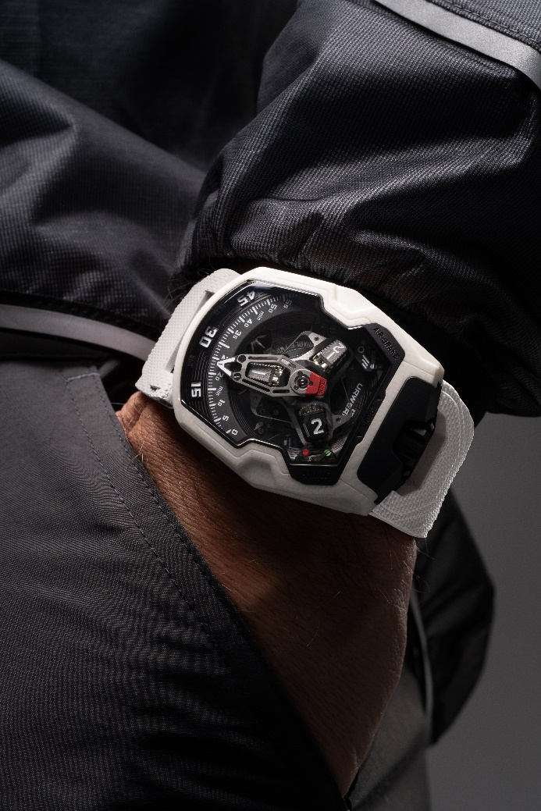

**The UR-230 Polaris**

Limited edition of 35 timepieces

**Technical Specifications.**

**Movement**

Caliber: UR-7.30 developed by URWERK

Winding:  Automatic winding mechanism with manual winding option

Escapement: Swiss anchor escapement

Frequency:  28,800 vph- 4 Hz

Hairspring:  Flat

Jewels: 50

Energy:  double barrel system

Power Reserve:  48 hours

Material:  Baseplate in ARCAP P40; 3D minute hand in aluminum with counterweight; Central spring in steel; Hour transporters in aluminum; Central carousel and screws in Grade 5 titanium.

**Finishes**: Hour markers hand-painted with SuperLumiNova ©; 3D-engraved structure with circular finish; Micro-bead blasted sub-dials; Sandblasted with circular satin finish and black rhodium coating carousel; Sandblasted with DLC coating cam; Black anodized and finely sandblasted 3D minute hand; Red anodized counterweight; Polished screws.

Hand-painted components with SuperLuminova © (White (blue glow): Hour transporter and markers, automatic winding indicator; red (green glow): 60-minute marker and "Off" position for automatic winding.

**Indications**

Wandering hours on a revolving satellite complication (URWERK patented); 3D retrograde minute hand; Air brake system for winding regulation; Automatic winding on/off indicator.

**Case**

Material: Exclusive white ceramic developed in collaboration with URWERK

Dimensions: Width: 44,81 mm; Length:  53,55 mm; Thickness: 18,38 mm

Crystal: Sapphire crystal

Case Back: Black DLC-treated titanium with sapphire crystal

Water resistance: Tested to 30 meters (3 ATM)

Strap: Vulcanised rubber ©, "Kiska" reference with Velcro closure

**Price** CHF 150,000 (Swiss francs / excluding tax)

____________________________

Media contact :

Ms Yacine Sar [press@urwerk.com](mailto:press@urwerk.com)

+41 22 900 2027

[www.urwerk.com/press](http://www.urwerk.com/press)