THE UR-300 Time Quantum BY URWERK
BEWARE: ATOMS IN MOTION

Geneva - October 15, 2026.
TAMING CHAOS, UNLEASHING PRECISION
The new collection from URWERK examines the building blocks of timekeeping, testing the equations that hold chronometry, energy and space in perfect equilibrium. The UR-300 Time Quantum takes the signature URWERK wandering hour into the realm of subatomic discourse, creating its own definitions of mechanical entanglement and Wirkungsquantum. Put away your satellite-spotting telescopes and get ready for a singular experience on the microscopic end of the space-time continuum.

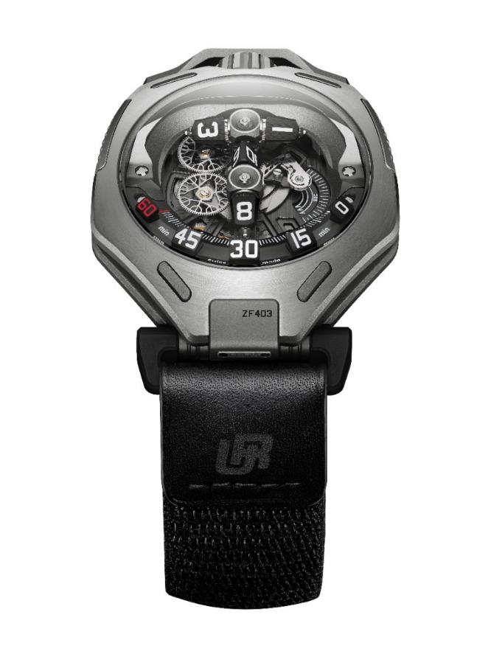

EVERYTHING, EVERYWHERE, ALL AT ONCE
After nearly three decades of exploring the natural world and outer space via its timepieces, URWERK breaches the final (and most mysterious) frontier of all — the invisible interactions of atoms and energy-charged particles that govern everything around us. No other phenomena can be considered as so fundamental and yet futuristic as quantum mechanics.
The new UR-300 Time Quantum inverts the lens on our view of the URWERK universe. Instead of orbital satellites on a rotating carousel, there are two polarised entities moving in entangled reflected symmetry. Instead of the retrograde snap that punctuates the URWERK catalogue from 2005’s Opus V (made in collaboration with Harry Winston) to 2024’s UR-150 Scorpion, the UR-300 introduces a quick-blink forward jump to signal the transition from one hour to the next. Instead of the multi-point choreography of swirling hour modules and skeletonised minute hands, there is just one controlled burst of accumulated power as the entire system instantaneously changes its state.
Felix Baumgartner, master watchmaker and co-founder of URWERK says “The world of the atom is fascinating because it exists in a state of constant, temporary equilibrium. Introduce energy into the system and its structure breaks down, reorganizes and shifts into a new state. That idea of transition is what I wanted to translate into mechanics with the UR-300. Beneath the sapphire crystal, you can watch a kind of ‘atomic’ reaction unfold in real time, as the elements move, interact and reconfigure before your eyes. Using the tools and expertise of watchmaking, we have tried to give mechanical form to the dynamic nature of matter.”

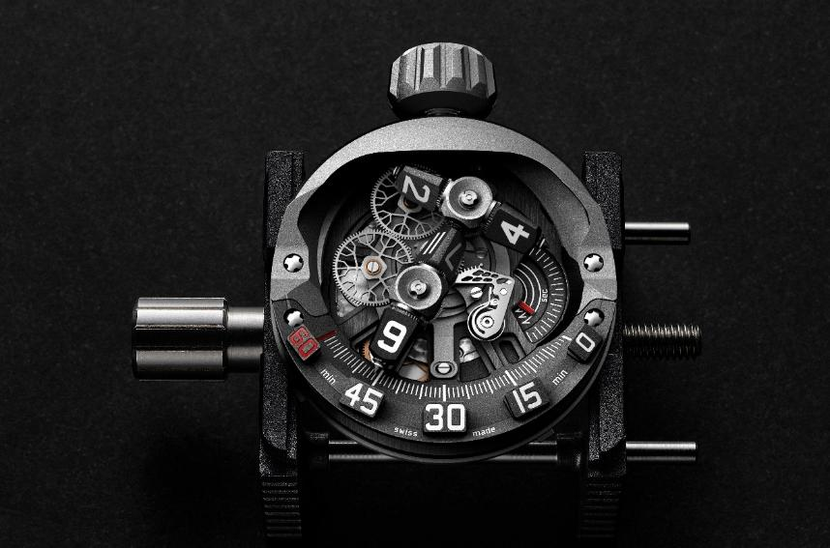

A step-by-step observation of the Time Quantum operating in flux:
Two hour modules of linear construction are fixed perpendicularly, forming a T-frame (T for Time). Both hour modules are double ended, holding a tri-sided hour prism at each end. Between them, the four tri-sided hour prisms indicate all the 12 hours of the clock.
The T-frame is calibrated so that the hour prism at the base of the T shows the correct hour, and travels along a 108° arc that is marked with the minutes from 0 to 60. As the base of the T arrives at the 60th minute mark, the T-frame undergoes a transformation.
Three events happen simultaneously to advance the time display on the UR-300. The entire T-frame jumps forward and rotates 72° to bring the next hour prism into position. What was previously the crossbar of the T pivots around its midpoint and becomes the new stem, coming into alignment with the 0 minute mark. The previous stem rotates in the opposite direction and becomes the new crossbar. At the same time, all the hour prisms spin, and the hour prism at the base of the new stem now displays the next hour.

Like charged molecules in stable tension, just one change in any variable — in this case, time — will cause the entire system to reconfigure itself and settle into a new equilibrium. It involves everything in the system, takes place everywhere in the system, and it happens all at once.

POWER UNDER CONTROL, EQUANIMITY IN MOTION
Beneath the spectacle of the UR-300 Time Quantum and its hourly entropic release is a carefully balanced equation that pushes watchmaking precision to its physical limits. From energy calculations to geometric tolerances, the pure cinema of the UR-300 in action is the result of applied microengineering at its finest.
The challenge of the UR-300 movement lies in the nucleus of its time indication concept. There have been URWERK timepieces with jumping or retrograde elements before, but never at this scale. Ironically, the piece that explores the theory of atomic interactions on the smallest level is also the project with the biggest technical ambitions. Effecting an instantaneous jump that consists of multiple high-inertia components with numerous points of mechanical vulnerability may sound straightforward on paper. Its execution in the real world, however, like all scientific endeavours, requires perseverance and an indefatigable spirit.

In constructing the UR-300 Time Quantum, the URWERK team were obliged to tread a fine path with atom-splitting accuracy. The energy of the jump must be sufficient to drive the entire sequence, but not so much that it creates visible recoil in the time display components, or puts unnecessary mechanical stress on the movement. The tolerances of each moving part must be enough to accommodate the sudden acceleration at every hour, but not so generous that the gear teeth are engaged too laxly and become inefficient.
The number of movement components must be optimised to reduce the load on the barrel and extend the power reserve as much as possible. However, as with every jumping mechanism, additional safeguards and systems must be included so that basic user functionality (for example, being able to set the time both forwards and backwards) can be preserved.
At every stage, considerations of performance and aesthetics had to be thoroughly weighed and factored into the final construction. In the end, the UR-300 Time Quantum is a relentlessly primed instrument, with a 44-hour power reserve in a 45.2mm by 58.8mm titanium case.

THE CONSTANCY OF CHANGE
While the URWERK UR-300 Time Quantum boldly ventures into new philosophical territories with brand founders Felix Baumgartner and Martin Frei as expedition leaders, there is still much about the watch that longtime URWERK followers will find familiar.
The T-frame hour modules that reconfigure and rebuild themselves in perfect tandem are meant to evoke the concept of quantum entanglement, where two particles can be observed to exhibit linked behaviour even when physically separated by distance.
Quantum theory is a loose analogue for the new thematic phase of URWERK. But are these domains really that different? Martin Frei, artistic director and co-founder of URWERK observes: “We have shifted scale, but from the infinitely large to the infinitely small, reality remains the same. From the orbit of planets to the dance of particles, it is all trajectories, encounters, attraction: invisible forces at work. But tilt the angle, move the point of reference, and time unveils another of its dimensions. Every hour, the mechanism disassembles and reassembles itself in the blink of an eye, faster than our minds can follow. Suddenly, processing speed becomes another fascinating ingredient in our search to expand the experience of time. At that moment, the person wearing the watch becomes part of the event. Time is no longer only something measured by the mechanism; it becomes something shaped by our own capacity to perceive change.”

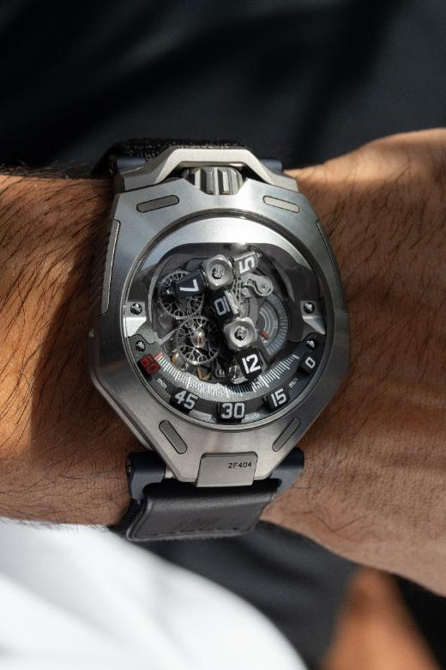

The URWERK UR-300 Time Quantum.
Limited edition of 25 pieces in titanium
and 25 pieces in titanium with AlTiN treatment.

Technical Specifications
Movement
Calibre | UR-30.01V, automatic winding regulated by Dual Flow Turbines (URWERK patented model)
Jewels | 40
Escapement | Swiss lever escapement
Balance wheel | Monometallic
Frequency | 4Hz / 28,800vph
Balance spring | Flat
Power source | Double mainspring barrel
Power reserve | 44 hours
Hour mechanism | Modular planetary complication (patent pending) with prograde hour modules mounted on planetary gears, controlled by cam, rack and spring; indexed by a Maltese cross.
Materials | Dual hour modules in Beryllium copper, brass, anodized aluminium; baseplate in ARCAP AP1D, titanium; LIGA-processed nickel.
Finishing | Circular and straight graining, sanding, côtes de Genève, chamfered and polished screw heads
Display | Modular complication with planetary reconfiguration (patent pending). Revolving modules in T configuration with prograde wandering hours indicator; minutes ; three hands showing 3 x 20seconds across 120°.
Case
Materials | Titanium Grade 5 for Titan model (25 timepieces) and  Titanium Grade 5 with DLC deposited by PE-CVD treatment for AlTiN model (25 timepieces)
Dimensions | 45.2mm x 58.8mm x 18.25mm
Crystal | Sapphire crystals with anti-reflective coating
Water resistance | Tested at 3ATM
Strap | Nato strap
Price | CHF 168’000.00 (tax not included)

ABOUT URWERK

As URWERK co-founder and master watchmaker Felix Baumgartner explains: “Our aim is not to offer yet another reinterpretation of a familiar mechanical complication. Our watches are unique because each model has required an original design process. Our ambition is to rethink the traditional boundaries of fine watchmaking and push them aside to forge our own path,” he concludes.
This spirit is echoed in the words of Martin Frei, the company’s artistic director and co-founder: “My artistic roots lie in boundless creativity. Freed from the constraints of classical watchmaking, I draw on my cultural heritage to forge a new aesthetic language.”

Although URWERK is a young company founded in 1997, it is regarded as a pioneer in the world of independent watchmaking. With an annual production of around 200 watches, URWERK is an artisan workshop where traditional craftsmanship and avant-garde aesthetics coexist to the full. URWERK designs complex, contemporary watches, unlike any others, which meet the most exacting criteria of Haute Horlogerie: independent research and creation; cutting-edge materials and hand-finishing.

The name URWERK has its roots in 6000 BC in the city of Ur in Mesopotamia. The Sumerians, observing the shadow cast by the sun on their monuments, were responsible for defining the unit of time as we still know it today. Whether by coincidence or as a sign of the times, the word ‘Ur’ also means ‘the beginning’ or ‘origins’ in German. The final syllable of the URWERK signature is also borrowed from the language of Goethe, the verb ‘werk’ meaning to create, to work, to innovate. A tribute to the tireless work of the master watchmakers who have succeeded one another right up to the present day, shaping what we now call Haute Horlogerie.

