The UR-230 “Black Star” plunges URWERK back into Black

Geneva – December 2025.
URWERK ends the year in sidereal black. The independent watchmaking house unveils its new UR-230 “Black Star,” a creation that does not seek light but instead absorbs it, engulfs it – the better to restore it on its own terms.
After the raw texture of the Carbon CTP in the “Eagle” and the mineral whiteness of the ceramic “Polaris”, the “Black Star” concludes the 230 collection triptych on a cosmic note. The curtain falls on a note of vibrant black: a gravitational field where light vanishes, only to be reborn in random flashes.
Welcome to the dark side of the URWERK force!

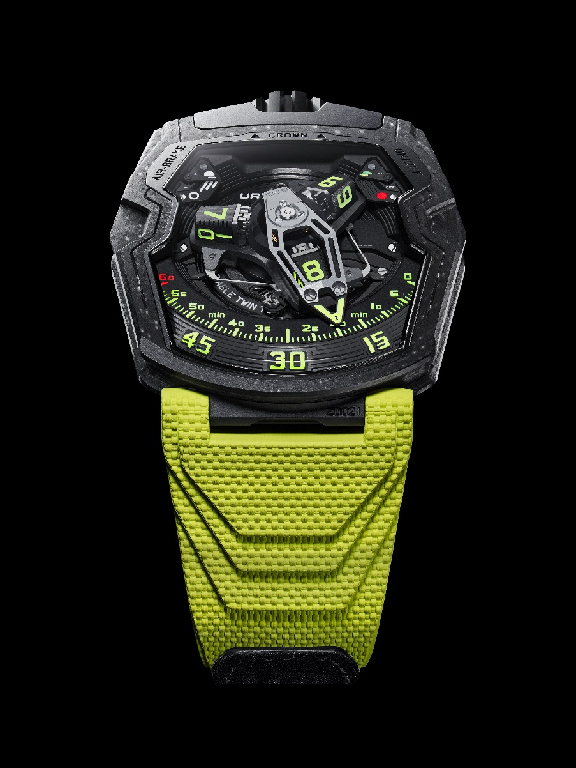

A highly protected mechanism
This UR-230 “Black Star” is original in more ways than one. First, there is its structure. Calibre UR-7.30 powering this creation is protected by a hermetic titanium container designed as a mechanical safe. Surrounding this highly protected heart, a composite ceramic case and a black DLC titanium back form the UR-230's shell: “I love the aesthetics of ceramic and its clean, precise look. It's a material that's hard, shiny, beautiful... and incredibly fragile. A single impact and it cracks – yet I didn't want to give up on this option”, explains Felix Baumgartner, master watchmaker and co-founder of URWERK. “We had to find a solution to fulfil this desire without making any comprises.”

The original, high-performance case of the UR-230 “Black Star” is made from a laminated composite ceramic developed specifically for URWERK: layers of braided ceramic, fibreglass and carbon fibre have been integrated into a polymer matrix. When machined, this unique ceramic reveals a shiny relief. Its flat, smooth surface is illuminated with sparkling dots, creating a dense, vibrant black-light texture.

Vibrant darkness
“While Polaris evoked the brightness of the North Star, Black Star belongs to the interstellar void”, says URWERK’s artistic director and co-founder Martin Frei. "This black is not there to conceal. It breathes. It makes light appear in a setting of shadows. In astrophysics, a Black Star refers to the state of a collapsing star. The star then absorbs light like a black hole, but not completely, just at the cosmic boundary between being and disappearing. URWERK's ‘Black Star’ embodies this paradoxical presence: a deep, living black that does not deny light but reveals it by draping it in shadows – a glow born from the very heart of the night."

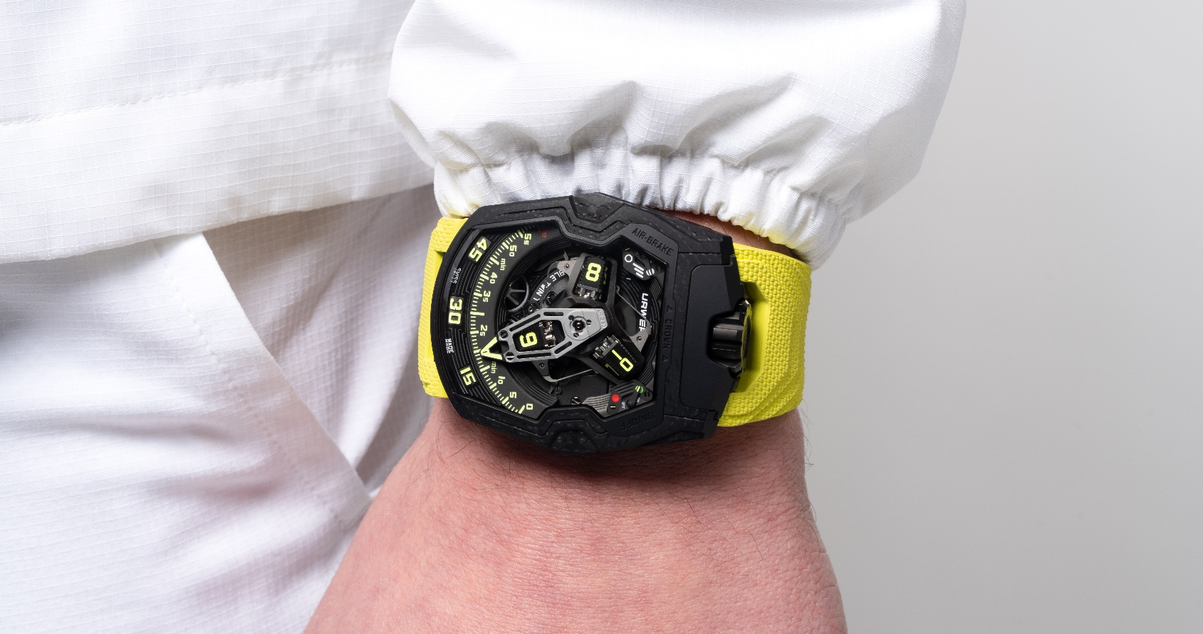

Wandering mechanics
The UR-230 “Black Star” embodies URWERK’s DNA. This new UR-230 features a satellite complication with wandering hours and a retrograde 3D hand; while a central hub connects three cubic hours satellites. These four-sided blocks move across a 120° sector in 60 minutes. The active hour – the one scrolling along this minutes rail – is taken charge of and put into orbit by an openworked retrograde hand that accompanies it throughout its journey from index 0 to 60. At the end of 60 minutes, the hand instantly flies back to zero to take charge of the next satellite.

Dual turbine system
The UR-230 is a self-winding watch regulated by an exclusive dual turbine system:
- one absorbs external shocks
- the other regulates the air flow of the automatic winding mechanism, acting as a true aerodynamic brake.
A control on the back allows the rotor load to be adjusted or even completely deactivated to switch to manual-winding mode.

Two symmetrical indicators − at 11 o'clock and 1 o'clock − display these settings.

This UR-230 “Black Star” concludes the 230 collection chapter. The end of a story, but with new adventures to follow in 2026...
Until then, Happy New Year!!!
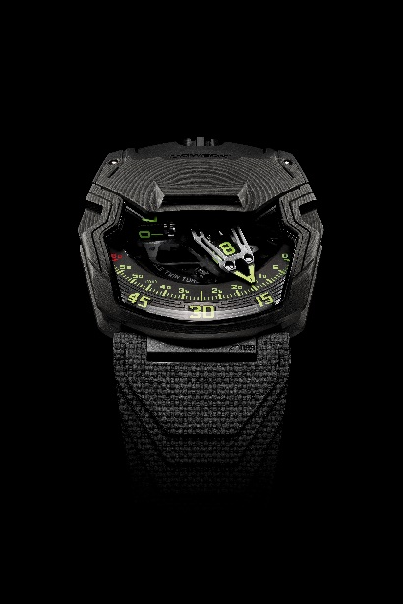 | 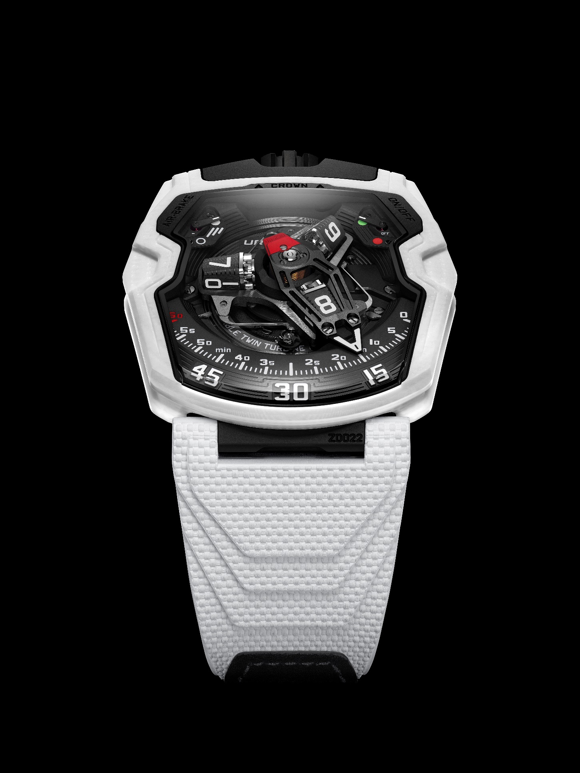 | 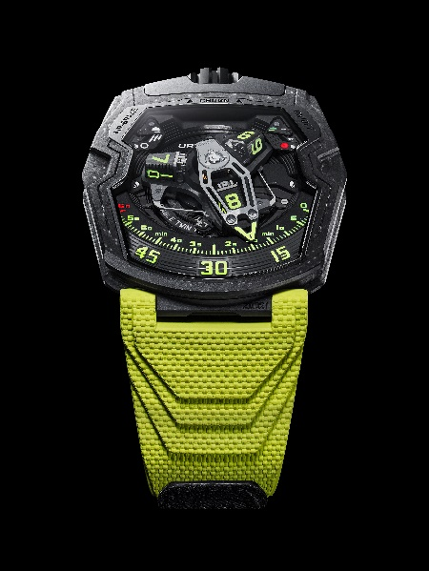
UR-230 Eagle | UR-230 Polaris | UR-230 Black Star

UR-230 Black Star – 35-piece limited edition

Technical specifications
Movement | Calibre UR-7.30 developed by URWERK
Winding | Modular automatic winding
Escapement | Swiss lever escapement
Frequency | 28,800 vph - 4 Hz
Balance | Variable inertia
Jewels | 50
Balance-spring | Flat
Energy | Double barrel
Power reserve | 48 hours
Materials | Baseplate in ARCAP P40, 3D minutes pointer in aluminium with counterweight;  Steel central spring; hours transporter in aluminium; central carrousel and screws in grade 5 titanium
Finitions | Hour-markers painted with Super-LumiNovaTM  Structure finely 3D-engraved with a circular satin-brushed pattern  Shotpeened satin-brushed subdial indications  Finely sandblasted carrousel with a shotpeened, circular satin-finished and black rhodium-plated cage  Finely sandblasted satellite cam with DLC coating  Finely sandblasted anodised 3D hand  Components hand-painted with Super-LumiNovaTM: yellow glowing blue for the hour-markers; yellow glowing blue for the automatic indication; red glowing green for the 60-minute marker and the OFF position of the automatic indicator; green for the ON indication.  Polished screws
Indications | Wandering hours on a satellite complication (URWERK patent)  3D retrograde minutes hand  Aerodynamic winding regulation indication (Air Brake)  Automatic winding status indication (On-Off)

Case
Material | Exclusive ceramic composite, developed with and for URWERK
Dimensions | Width: 44.81 mm; length: 53.55 mm; thickness: 14.30 mm
Glass | Transparent sapphire crystal
Caseback | Black DLC-treated titanium and sapphire crystal glasses
Water resistance | Pressure-tested to 30 m/3 ATM
Strap | Vulcanized© rubber, “Kiska” reference. Velcro fastening
Price | CHF 150,000 (Swiss francs / excluding tax)

________________________________

Press contact:
Ms Yacine Sar
press@urwerk.com
+41 22 900 2027
www.urwerk.com/press

ABOUT URWERK
“Right from the start, we refused to confine ourselves to the well-beaten track of traditional complicated mechanisms”, explains watchmaker Felix Baumgartner, master-watchmaker and co-founder of URWERK. “Our aim is to go beyond the traditional horizons of watchmaking and to overturn them so as to blaze our own trail”, he concludes. The original styling of each URWERK model is signed by chief designer Martin Frei, the company’s other co-founder, who shares: “I come from a background where creativeness has no limits. I am in no way prisoner of the traditional constraints of watchmaking and I can therefore be freely inspired by my cultural heritage.”

Although URWERK is a young company established in 1997, it is recognized as a pioneer among independent watchmakers. Producing just 150 watches a year, The Swiss Maison sees itself as a veritable laboratory where traditional expertise rubs shoulders with avantgarde styling. Its range of creations comprises three distinct lines: URWERK’s iconic Satellite collection in which wandering hours redefine our perception of time; the Chronometry collection, an experimental field dedicated to precision and mechanical innovation; along with Special Projects, an area dedicated to daring expression and visionary concepts.
URWERK develops modern and complex watches that are unprecedented and meet watchmaking’s most demanding criteria: independent design and research, advanced materials and handcrafted finishes.

The name URWERK comes from the ancient city of Ur of the Chaldees in Mesopotamia, founded nearly 6,000 years ago where the Sumerian inhabitants first established units of time based on the shadows cast by its monuments. Ur in the German language also means primeval or original and Werk means an achievement or a mechanism. Thus, URWERK can be translated as an original movement – a tribute to generations of watchmakers whose work has resulted in what we know today as Haute Horlogerie, or superlative watchmaking.

